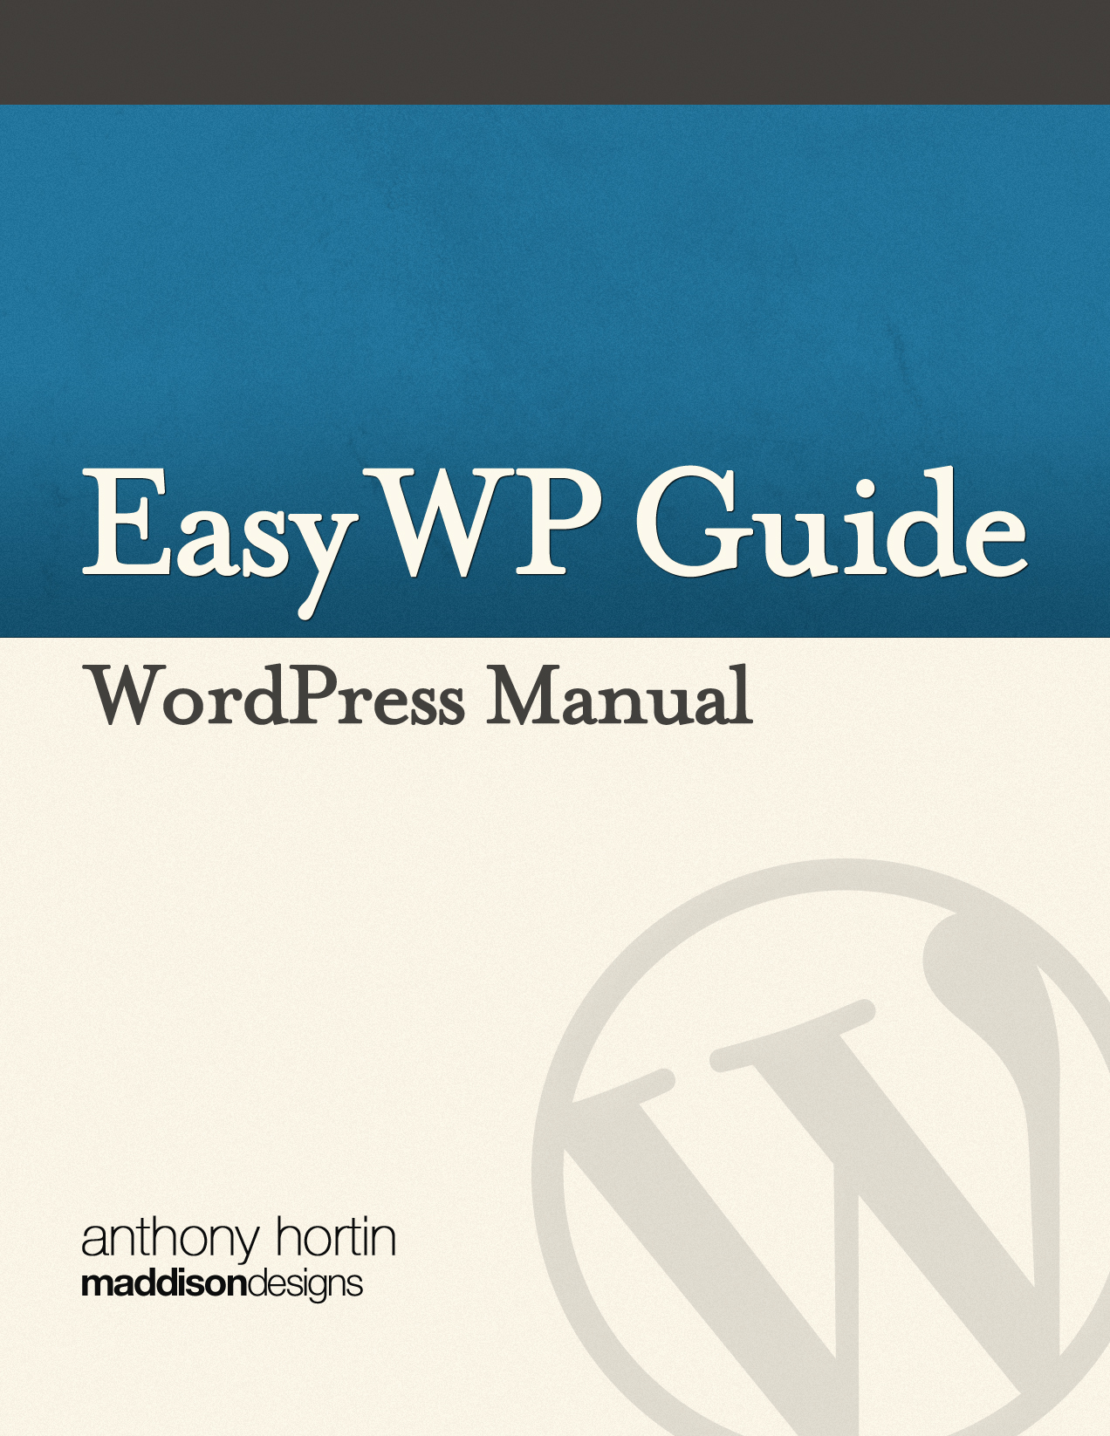

Easy WP Guide WordPress Manual

by Anthony Hortin

Maddison Designs[maddisondesigns.com](http://maddisondesigns.com)

Copyright © 2013 Anthony Hortin

All rights reserved

|  |  |
| --- | --- |
| Crafted |  |

Published August 2013Version: 2.5 for WordPress 3.6

ISBN: 978-0-9872955-3-8

[easywpguide.com](http://easywpguide.com)

Contents

Welcome 7

Introduction 8

Login 10

Dashboard 11

Dashboard Menu Options 12

Toolbar 14

Hiding the Toolbar 15

Posts 16

Pages 18

Adding your Site Content 20

Adding a New Page 20

Adding a New Post 21

Adding Content with the Visual Editor 23

Switching to the Text Editor 26

Changing your Post Format 28

Reviewing Past Revisions 29

Adding Images and Other Media 32

Inserting an Image 32

Edit or Delete an Image 37

Setting a Featured Image 41

Insert an Image Gallery 43

Edit or Delete an Image Gallery 45

Inserting Video, Audio or Other File Type 46

Embedding a Video, Image or Other Content 47

Adding HTML Links 49

Inserting an HTML Link 49

Editing an HTML Link 50

Removing an HTML Link 50

Editing Existing Content 51

Deleting Content 52

Fullscreen Editing 54

Saving and Publishing Content 56

Categories 58

Adding Categories within your Post 60

Tags 62

Adding Tags within your Post 64

Media Library 66

Viewing a File in the Media Library 66

Adding a File to the Media Library 67

Editing the File Properties 67

Editing an Image 69

Deleting a File from the Media Library 72

Links 73

Adding a New Link 74

Edit an Existing Link 76

Delete an Existing Link 76

Updating Link Categories 77

Comments 79

Replying to a Comment 80

Editing a Comment 83

Quick edit 83

Edit 83

Unapproving and Approving Comments 84

Marking Comments as Spam and Trash 84

Appearance 86

Selecting your Theme 86

Previewing and Customizing your Theme 87

Widgets 88

Updating the Menu 90

Adding a New Menu 92

Editing an Existing Menu Item 92

Adding a New Menu Item 93

Adding a Custom Link Menu Item 94

Deleting a Menu Item 94

Managing Menu Locations 94

Header 95

Background 95

Editor 95

Plugins 96

Users 97

Adding a New User 98

Deleting a User 99

Editing your Profile 100

Tools 104

Press This 104

Categories and Tags Converter 104

Import 104

Export 104

Settings 105

General 105

Writing 106

Reading 107

Discussion 108

Media 110

Permalinks 110

Where To From Here? 112

Welcome

It might be easier to say what this guide isn’t, rather than what it is. It isn’t an in depth look at every single function available within the WordPress dashboard. Nor is it a guide to help you develop or modify WordPress themes. My aim is to create a simple WordPress guide that will help you to get an overall understanding of how you use the various features within the WordPress Dashboard to keep your site or blog updated.

If you’re looking for more in-depth knowledge, there are heaps of articles in the [WordPress Codex](http://codex.wordpress.org/Main_Page) that go into more detail. This is great if you want to get really involved in developing your own WordPress theme or modifying your site with plugins, but it can be a bit daunting for those users who just want a simple guide to using the Content Management side of WordPress or just need to update their site pages every so often.

Introduction

WordPress is an [Open Source](http://en.wikipedia.org/wiki/Open_source) software system used by millions of people around the world to create beautiful websites and blogs. It is completely customisable by the use of [themes](http://wordpress.org/extend/themes) and [plugins](http://wordpress.org/extend/plugins).

“WordPress is web software you can use to create a beautiful website or blog. We like to say that WordPress is both free and priceless at the same time.”

Themes can be easily downloaded from the WordPress site or from hundreds of other places around the web. The same goes with plugins, which are used to extend the functionality of your WordPress site.

WordPress is built around two basic concepts. Posts and Pages. Posts are typical blog entries. A series of articles, listed (usually) reverse-chronologically. Pages are used for more static content (i.e. content that doesn’t change or changes infrequently). An ‘About us’ page is an example of a Page on a typical website. In most cases you’ll find that the content in the ‘About us’ page doesn’t change all that frequently.

Now, you might be thinking, “but I don’t need a blog”. This might be true, but you can also use the blog concept if you have a site where you need to display your ‘latest news’ or even just company updates. Basically, any information that gets updated on a semi-regular basis can benefit from the ‘blog’ functionality. Whether that’s a traditional blog, your company’ ‘latest news’ or even just your own personal updates.

The following are just a very few examples of the millions of diverse sites powered by WordPress...

The Rolling Stones – [http://www.rollingstones.com](http://www.rollingstones.com/)A 50th anniversary overhaul for the website of the World’s Greatest Rock ‘N’ Roll Band, including a complete discography managed entirely within WordPress, tightly integrated with iTunes.

Best Buy Mobile – [http://bestbuymobile.com](http://bestbuymobile.com/)An online magazine that showcases the latest gadgets, apps, and technologies in the consumer mobile industry.

365 Awesome Designers – [http://365awesomedesigners.com](http://365awesomedesigners.com/)A little project by mment industries, where he will publish a designer every day for the next year. It uses a innovatively designed custom WordPress theme to showcase the design work of a new designer each day.

Xzibit – [http://xzibit.com](http://xzibit.com/)Music, video, and news about the rapper, actor, and television host, Xzibit.

UCF College of Medicine – [http://www.med.ucf.edu](http://www.med.ucf.edu/)The UCF College of Medicine is one of the first U.S. medical schools in decades to be built from the ground up. As a new medical school, UCF’s program epitomises innovation, high-tech learning tools and a pioneering spirit to educate young doctors and scientists in a new and better way for the 21st century.

Mashable – <http://mashable.com>With more than 5 million monthly page views, Mashable is the world’s largest blog focused exclusively on social networks.

Login

Before you can make any changes to your site, you will need to log in. The login for your site is typically found at the following URL - http://your-wordpress-site.com/wp-admin. Obviously, replace your-wordpress-site.com with your actual domain name.

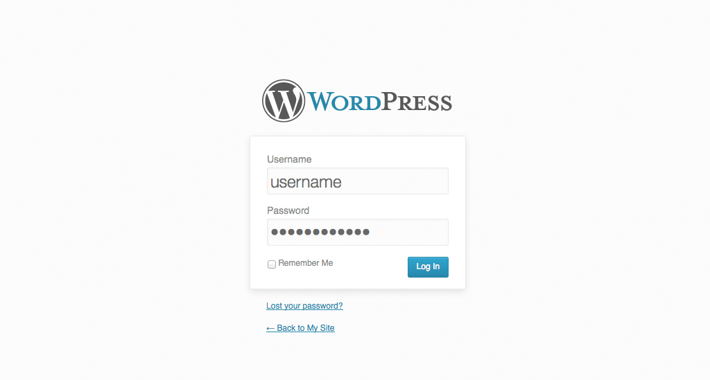

There are exceptions to this of course. For instance, your WordPress setup maybe installed in a subdirectory. For most standard setups though, you’ll find the above [URL](http://en.wikipedia.org/wiki/Url) should work.

Dashboard

Once you’ve logged in, the WordPress Dashboard appears. This is your main administration homepage. At the very top of your Dashboard (and across every page) you will see the name of your site in the header area. In the example screenshot below (and throughout this documentation) the site name is My Site. This is also hyperlinked to your site's homepage. You will also see the name of the person who is currently logged in (e.g. Joe Blogg). Move your cursor over your name to reveal the Log Out link as well as a link to edit your Profile.

When new or updated features are introduced into WordPress, you’ll be shown a New Feature Pointer. This is simply to bring to your attention some feature within the Dashboard that’s been added or updated. In the following Dashboard image, the New Feature Pointer is highlighting the updated Toolbar. Click Dismiss to hide the pointer.

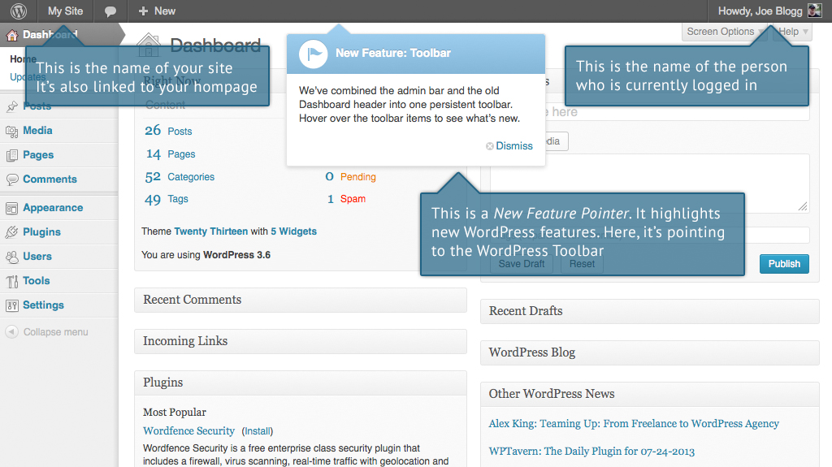

On most pages, just below your Username there are a couple of small inverted tabs. One called Screen Options and another called Help. Clicking either of these links will cause a panel to slide down from the top of the page. The Help link obviously displays some help information. The Screen Options link will display various options that allow you to configure what is displayed on the current page. The details in this panel change depending on what page you’re currently viewing. As an example, on your main Dashboard page the Screen Options allow you to set which panels you’d like displayed on the page and also how many columns you’d like the panels to appear across.

## Dashboard Menu Options

Down the left hand side of the Dashboard and on every page you will see your main admin navigation menu. This is where you’ll find all the options to update and configure your site.

Hovering your cursor over each of the main menu options will display a ‘fly-out’ menu with the various choices for that particular menu option. Once you click each of the main menu options, that particular menu will expand to show all the available options within that section (if there are any).

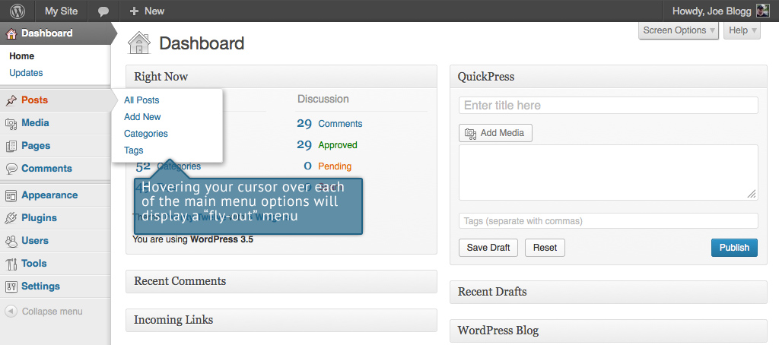

The main menu options and their usage are:

Dashboard

This will display your main Dashboard ‘homepage’. In the top left of your Dashboard you’ll see some brief stats on the number of Posts, Pages, Categories and Tags contained within your site, as well as the total number of comments and approved comments. There’s also a summary of how many [Spam Comments](http://en.wikipedia.org/wiki/Spam_(electronic)) you currently have.

Posts

This is where you can create a new Blog Post. You can also update your Categories and Post Tags.

Media

This is where all your uploaded images, documents or files are stored. You can browse through your Media library, as well as edit and update the files.

Links

In WordPress 3.5 the Link Manager is disabled by default, to help simplify the Dashboard interface. The previous screenshot shows the Dashboard menu without this Links menu option. When you update to WordPress 3.5, if you are currently using the Links Manager, then it will remain enabled for you. If you’re not currently using it or if you’re installing WordPress for the first time, and would like to use it, you can download the [Link Manager plugin](http://wordpress.org/extend/plugins/link-manager/) from the WordPress Plugin Directory. Once activated, this will enable the Links option in your Dashboard menu.

The Link Manager is used to add website links on your site. The links added in here are usually displayed in list form using one of the WordPress Widgets (as opposed to links that you simply create within a Post or Page). Links can also be divided into Categories.

Pages

This is where you create and maintain all your Pages.

Comments

You can manage all your Comments within this section, including replying to comments or marking them as Spam.

Appearance

This menu is where you control how your site looks. You can choose a new Theme, manage your site Widgets or Menus and even edit your site theme files.

Plugins

Plugins extend and expand the functionality of WordPress. You can add or delete plugins within here as well as activate or deactivate them.

Users

This screen lists all the existing users for your site. Depending on your Role, you can also add new users as well as manage their Roles.

Tools

This section gives you access to various convenient tools. You can also Import data to your WordPress site or Export all your WordPress data to a file.

Settings

This is where your site is configured. Among other things, it allows you to configure your site name and URL , where your Posts appear, whether people can leave Post Comments or not and numerous other settings. Most times, once your site is setup, there's no need to change any of the settings within this section.

At the bottom of the menu you'll see a link called Collapse menu. Clicking this will hide the menu and simply display their icons instead. Click the small arrow icon again to expand the menu.

Occasionally when you install a Plugin, they will have their own configuration or setup pages. The location of these will be entirely dependent on the individual Plugin but most times these pages will either appear within the Tools section, the Settings section or in a completely new menu section at the bottom of the menu.

## Toolbar

The WordPress Toolbar is a way of easily accessing some of the most common WordPress features. When you are logged into your WordPress dashboard and you visit your website, you will see the Toolbar running across the top of your site. This bar only appears if you are currently logged into your WordPress site, which means that it won’t be visible to your everyday site visitors. If you are not logged in, the Toolbar won’t be displayed.

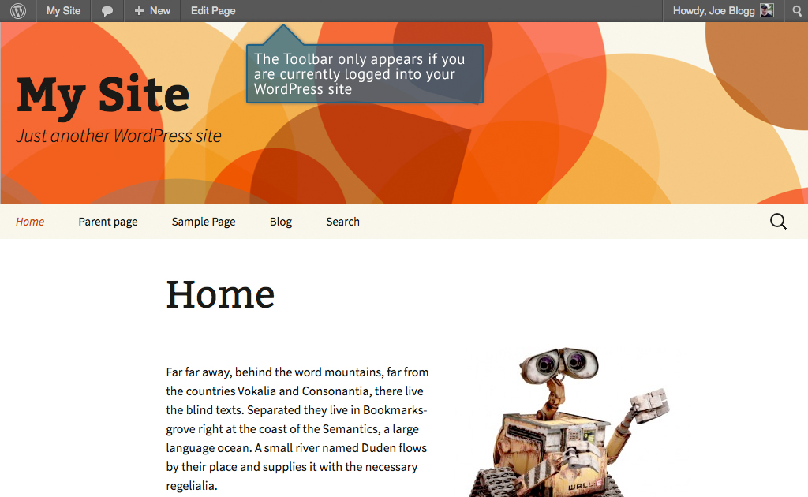

The Toolbar allows you to quickly access the following commonly used features.

* Visit the WordPress.org website, Codex or Support forums
* Display your site Dashboard and other commonly used menu options that allow you to update your site Themes, Widgets, Menus and depending on your theme, Background and Header
* View or Edit your blog comments
* Add a new Post, Media, Page or User
* Edit the current Page or Post
* Perform a site Search
* View or Edit your Profile and logout from the WordPress Dashboard

### Hiding the Toolbar

You can stop the Toolbar from displaying by modifying the preferences associated with your Profile. Simply click on the Users link in the left hand navigation to display the list of Users. From this list of Users, click your user name or click on the Edit link that appears beneath the user name when hovering your cursor over each row. Alternatively, click on the Your Profile link underneath the Users menu option in the left hand navigation or within the fly-out menu.

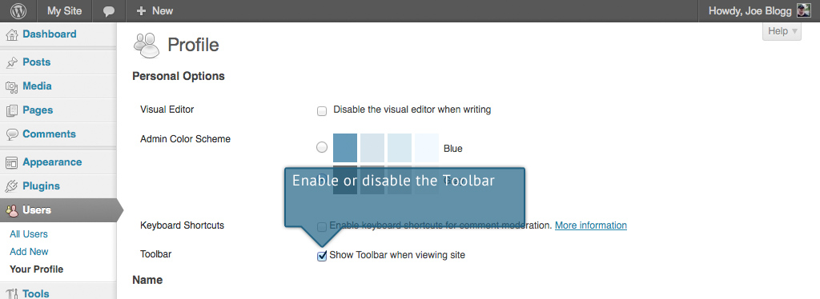

When editing your Profile there is a Toolbar option as shown in the screen above.

* Show Toolbar when viewing site – Checking this box will display the Toolbar at the very top of your website (only for the person who is currently logged in)

In WordPress 3.3 the header area was merged with the Toolbar and there is no longer an option to hide the Toolbar in the Dashboard as there was previously.

Posts

After clicking on the Posts menu option you'll be shown a list of Posts that your site contains. Among the information displayed is the Post title, the Author, Categories, Tags, No. of Comments and either the Date Published, Date Scheduled or the Date the Post was Last Modified. The Posts screen will look similar to the screen below.

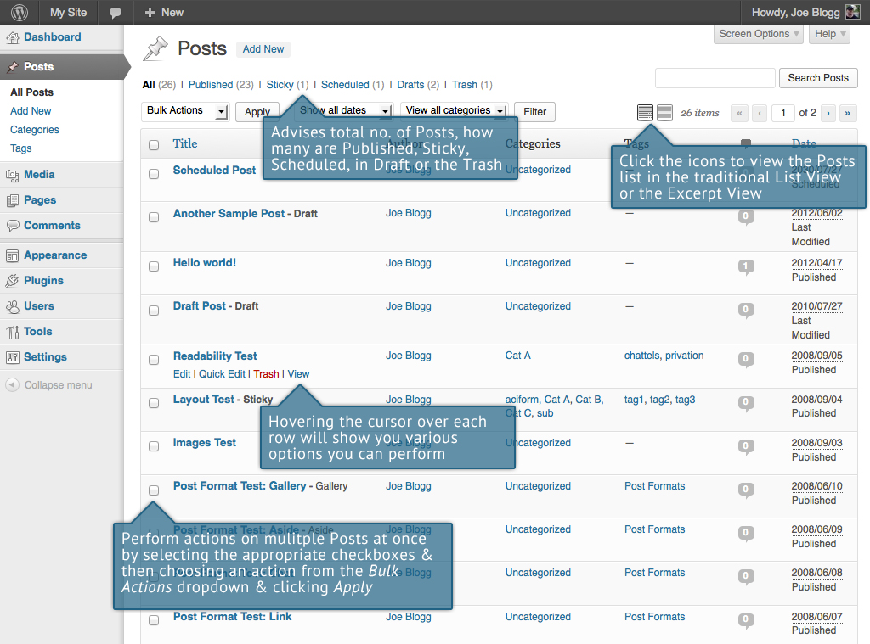

At the top of the page you can view how many Posts in total you have in your site, how many are Published, Scheduled, Sticky, Pending, in Draft or in the Trash.

When hovering your cursor over each row, a few links will appear beneath the Post title.

* Edit – Will allow you to edit your Post. This is the same as clicking on the Post title
* Quick Edit – Allows you to edit basic Post information such as Title, Slug, Date plus a few other options
* Trash – Will send the Post to the Trash. Once the Trash is emptied, the page is deleted
* View – Displays the Post. If the Post hasn’t been published yet, this will say Preview

Next to each Post title is a checkbox. This allows you to perform an action on multiple items at once. You simply check the Posts that you would like to affect and then from the Bulk Actions dropdown select either the Edit option or the Move to Trash option and then click the Apply button. The Edit option will allow you to edit the Categories, Tags, Author, whether to allow Comments and Pings or not, the Status and whether or not the Posts are ‘Sticky’. The Move to Trash option will move the selected items to the Trash.

You can also filter the pages that are displayed using the dropdown lists and the Filter button.

At the top of the list of Posts there are also two icons that change how the list is displayed. Click the List View icon () to display the posts in the traditional List View or click the Excerpt View icon () to display a short excerpt from the Post underneath the Post title.

Pages

After clicking on the Pages menu option you'll be shown a list of Pages that your site contains. Among the information displayed is the Page title, the Author, No. of Comments and either the Date Published or the Date the Page was Last Modified. The Pages screen will look similar to screen below.

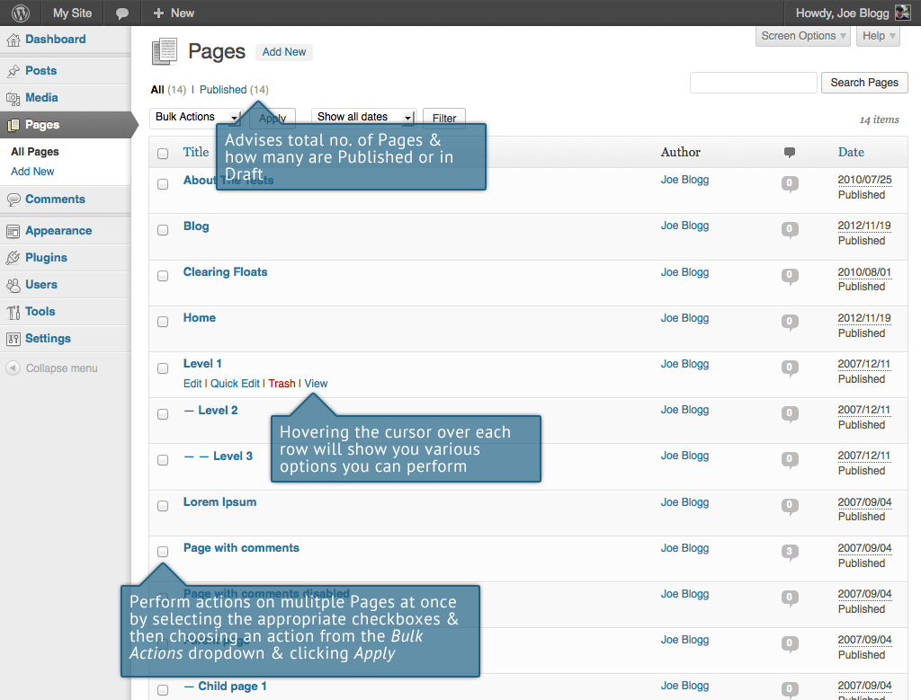

At the top of the page you can view how many Pages in total you have in your site and how many are Published or in Draft.

When hovering your cursor over each row, a few links will appear beneath the Page title.

* Edit – Will allow you to edit your Page. This is the same as clicking on the Page title
* Quick Edit – Allows you to edit basic Page information such as Title, Slug, Date plus a few other options
* Trash – Will send the Page to the Trash. Once the Trash is emptied, the page is deleted
* View – Displays the Page. If the Page hasn’t been published yet, this will say Preview

Next to each Page title is a checkbox. This allows you to perform an action on multiple items at once. You simply check the Pages that you would like to affect and then from the Bulk Actions dropdown select either the Edit option or the Move to Trash option and then click the Apply button. The Edit option will allow you to edit the Author, Parent, Template, whether to allow Comments or not and the Status of each of the checked items. The Move to Trash option will move the selected items to the Trash.

You can also filter the pages that are displayed using the dropdown list and the Filter button.

Adding your Site Content

Adding content to your site is an easy process no matter whether you’re creating a Post or a Page. The procedure for both is almost identical. Apart from how they display on your site, which was described earlier, the other main difference is that Posts allow you to associate [Categories](http://codex.wordpress.org/Posts_Categories_SubPanel) and [Tags](http://codex.wordpress.org/Posts_Post_Tags_SubPanel) whereas Pages don’t. What’s the difference between categories and tags? Normally, Tags are ad-hoc keywords that identify important information in your Post (names, subjects, etc) that may or may not recur in other Posts, while Categories are pre-determined sections. If you think of your site like a book, the Categories are like the Table of Contents and the Tags are like the terms in the index.

## Adding a New Page

To add a new Page, hover your cursor over the Pages menu option in the left hand navigation menu and in the fly-out menu, click the Add New link. Alternatively, click the Pages menu option and then click the Add New link underneath, or the Add New button at the top of the page. You will be presented with a page similar to the image below.

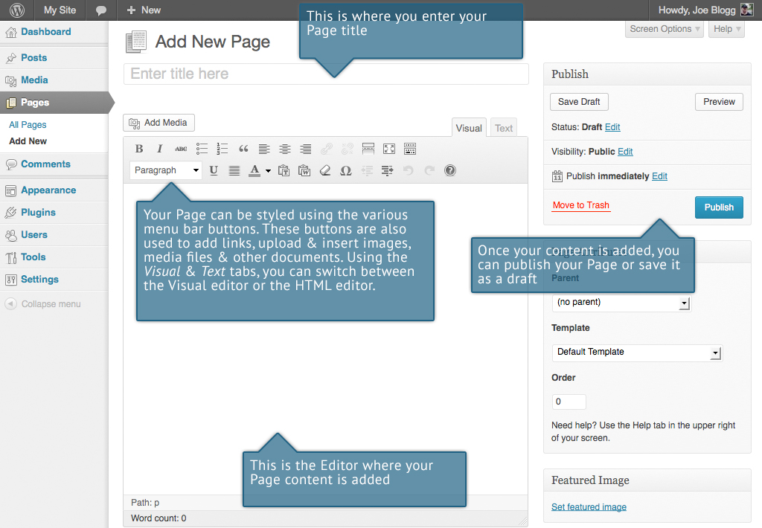

## Adding a New Post

To add a new Post, hover over the Posts menu option in the left hand navigation menu and in the fly-out menu, click the Add New link. Alternatively, click the Posts menu option and then click the Add New link underneath, or the Add New button at the top of the page. You will be presented with a page similar to the image below.

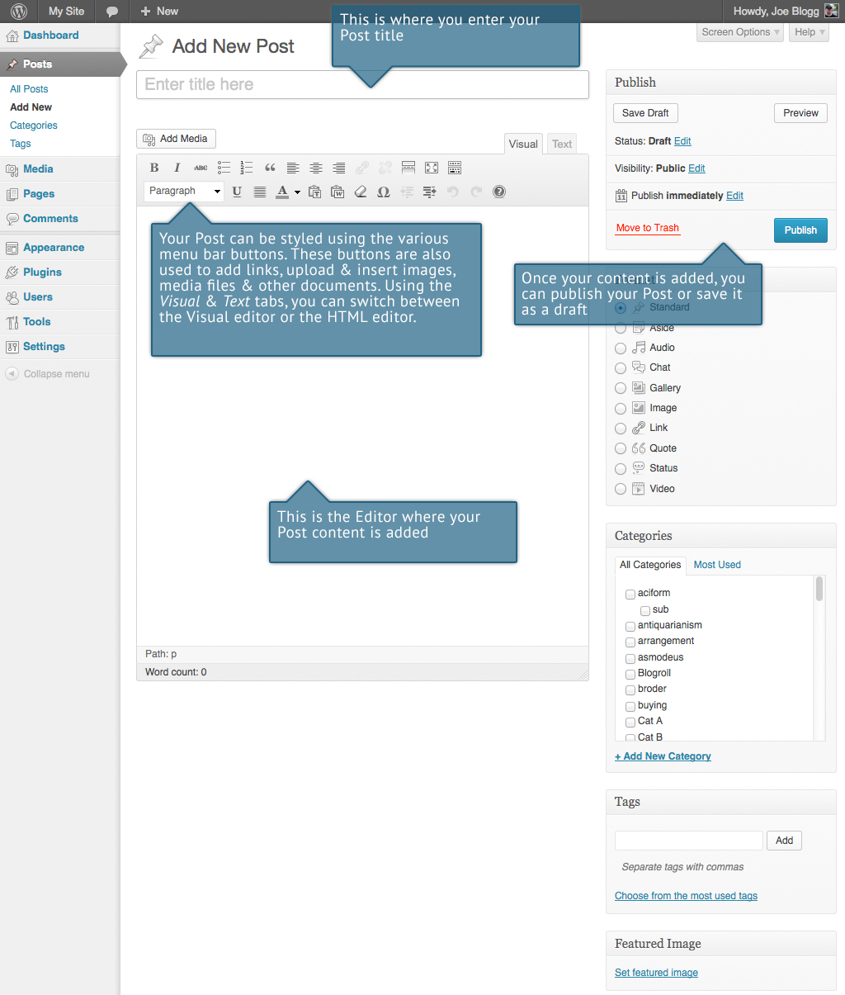

## Adding Content with the Visual Editor

The editor used to enter content into your Page or Post is very easy to use. It’s much like using a regular word processor, with toolbar buttons that allow you to Bold () or Italicize () text or enter in Headings () or bullet points (). You can even use most of the basic keyboard shortcuts used in other text editors. For example: Shift+Enter inserts a line break, Ctrl+C/Cmd+C = copy, Ctrl+X/Cmd+X = cut, Ctrl+Z/Cmd+Z = undo, Ctrl+Y/Cmd+Y = redo, Ctrl+A/Cmd+A = select all, etc. (use the Ctrl key on a PC or the Command key on a Mac).

At the top of the editor there are two tabs, Visual and Text (). These switch the editor view between the Visual editor and the Text editor. The Text view will enable you to view the HTML code that makes up your content. For the more experienced users this can be helpful at times but for those not familiar with HTML tags, it’s not recommended.

When creating a new Page or Post, the first thing to do is enter in your title in the top entry field where it says Enter title here. After moving the cursor down to the editor a new [Permalink](http://codex.wordpress.org/Using_Permalinks) is created for your page. Permalinks are the permanent URL’s to your individual Posts, Pages, Categories etc.. Though not usually necessary, you can manually edit your permalink by clicking on the actual permalink (the part after the domain name with the yellow background) or by clicking the Edit button next to it. Once you’ve modified it, click Ok to save or Cancel to cancel your changes.

At the top of the editor where your content is written, there are numerous formatting buttons. Clicking the Show/Hide Kitchen Sink button () will show or hide a second line of formatting buttons which gives you extra functionality. The editor buttons perform the following functions:

|  |  |
| --- | --- |
|  | Add Media – Used to upload and insert media such as images, audio, video or documents |
|  | Bold – Bold text |
|  | Italic – Italicise text |
|  | Strikethrough – Add a strikethrough to your text |
|  | Unordered List – Create an unordered (bullet point) list |
|  | Ordered List – Create an Ordered (numbered) list |
|  | Blockquote – Used as a way of showing a quote. How this looks will be entirely dependent on the Theme that your site is currently using |
|  | Align Left – Align text to the left |
|  | Align Center – Align text in the center of the page |
|  | Align Right – Align text to the right |
|  | Insert/edit link – Used to create an html link to another page or website. The text or image that you want to link needs to be selected first before the button will become active |
|  | Unlink – Remove the html link from the selected link. Your cursor must be sitting on an active link for the button to be active |
|  | Insert More tag – Inserts the More tag into your Page. Most blogs only display a small excerpt of a Post and you’re required to click the Post title or a ‘Read more...’ link to continue reading the rest of the article. When you insert a ‘More’ tag into your Post, everything prior to the tag is considered as this excerpt. Most times you’d only use this button when you’re creating a blog Post, rather than a Page |
|  | Toggle fullscreen mode – Clicking this button will enlarge the editor so that it fills the browser window. Clicking the Exit fullscreen link at the top of the screen will reduce it back to its original size |
|  | Show/Hide Kitchen Sink – Used to show or hide the second row of formatting buttons on the editor toolbar |
|  | Style – Used to format the Page text based on the styles used by the current Theme |
|  | Underline – Underline your text |
|  | Align Full – Align text on both the left and right (i.e. justify) |
|  | Select text color – Use to change the color of text |
|  | Paste as Plain Text – Copying and pasting text from other sites or word processors sometimes leaves the text formatted differently to what you were expecting. The reason for this is that quite often the html tags or codes that formatted the original text are pasted along with the text itself. To avoid this, Paste as Plain Text will strip all these formatting and html tags. Checking the keep linebreaks checkbox will preserve all HTML <br /> tags. Unchecking this option will remove them |
|  | Paste from Word – Pasting text from MS Word typically includes a huge amount of extra unrequired HTML tags which usually leaves the text formatted incorrectly. Using the Paste from Word option will remove these additional tags and clean up the HTML |
|  | Remove formatting – Use this to remove all the formatting (e.g. Bold, Underline, text color etc..) from the highlighted text |
|  | Insert custom character – Used to insert special characters not easily accessible via the keyboard (e.g. ¼, ½, ¾, ©, €, ö etc..) |
|  | Outdent – Removes one level of indenting |
|  | Indent – Indents text by one level |
|  | Undo – Undo your last action |
|  | Redo – Redo your last action |
|  | Help – Displays information about the WordPress visual editor along with keyboard shortcuts |
|  | Visual/Text – Switches the editor view between the Visual Editor and the Text editor. The Text view will enable you to view the HTML code that makes up your content. For the more experienced users this can be helpful at times but for those not familiar with HTML tags, it’s not recommended |

## Switching to the Text Editor

At the top of the editor there are two tabs, Visual and Text (). These switch the editor view between the Visual editor and the Text editor. The Text view will enable you to view the HTML code that makes up your content. For the more experienced users this can be helpful at times but for those not familiar with HTML tags, it’s not recommended.

The Text editor is much like the Visual editor, only not as intuitive. The numerous formatting buttons provide you with basic HTML formatting capabilities when editing your Page or Post content.

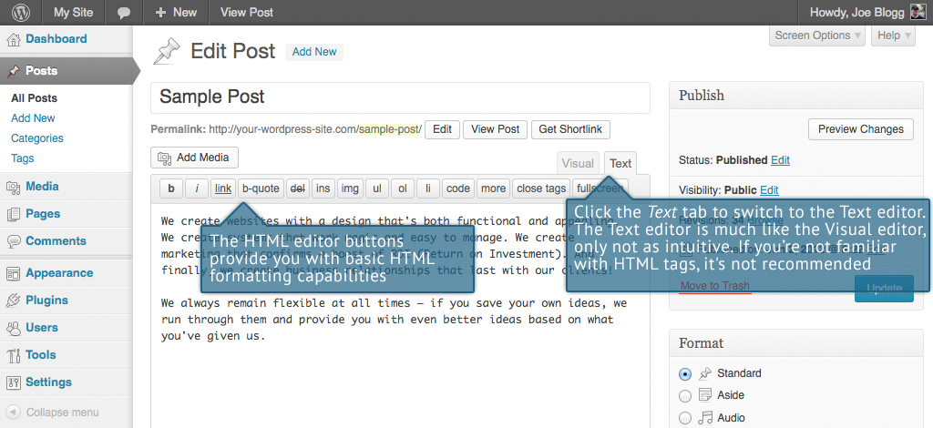

The buttons work in two ways. Clicking a button without highlighting any text first, will simply insert the opening HTML tag relevant for that button. As an example, clicking the Bold button will insert the <strong> HTML tag into your text. Clicking the Bold button again will close the tag by inserting the closing </strong> tag. If you highlight some text prior to clicking a button, both the opening and closing tags will be inserted around that highlighted text. For example, highlighting the text, ‘bold text’, prior to clicking the Bold button will insert ‘<strong>bold text</strong>’.

The following editor buttons are available whilst in the Text editor:

|  |  |
| --- | --- |
|  | Bold – Bold text |
|  | Italic – Italicise text |
|  | Link – Used to insert a website link. When the button is clicked a popup window will appear where you type in the URL that you would like to link to |
|  | Blockquote – Used as a way of showing a quote. How this looks will be entirely dependent on the Theme that your site is currently using |
|  | Delete – Used as a way of showing deleted text. How this looks will be dependent on the Theme but is usually done by showing the text with a strikethrough |
|  | Insert – Used as a way of showing inserted text. How this looks will be dependent on the Theme but is usually done by showing the text with an underline |
|  | Image – Used to insert an image into the text. When the button is clicked a popup window will appear where you type in the URL of the image that you would like inserted |
|  | Unordered List – Used to insert an unordered (bullet point) list |
|  | Ordered List – Used to insert an ordered (numbered) list |
|  | List Item – Used to insert a list item into your ordered or un-ordered list |
|  | Code –Used for indicating a piece of code |
|  | More – Inserts the More tag into your Page. Most blogs only display a small excerpt of a Post and you’re required to click the Post title or a ‘Read more...’ link to continue reading the rest of the article. When you insert a ‘More’ tag into your Post, everything prior to the tag is considered as this excerpt. Most times you’d only use this button when you’re creating a blog Post, rather than a Page |
|  | Close Tags – Used to close open tags. If for example, you clicked both the Bold and Italic buttons to insert their opening tags, clicking the Close tags button will insert both of the matching closing tags, in the correct order |
|  | Toggle fullscreen mode – Clicking this button will enlarge the editor so that it fills the browser window. Clicking the Exit fullscreen link at the top of the screen will reduce it back to its original size |

## Changing your Post Format

A Post Format is meta information that can be used within a Theme to style or customise the presentation of a Post. The Post Formats feature provides a standardised list of formats that are available to all themes that support the feature. There is no requirement for Themes to support every format on the list and new formats cannot be introduced by themes or even plugins. If your Theme supports Post Formats you can choose how each Post looks by selecting a Post Format from a list of radio buttons, similar to the following screen. If your Theme doesn’t support Post Formats then the Format panel won’t be displayed.

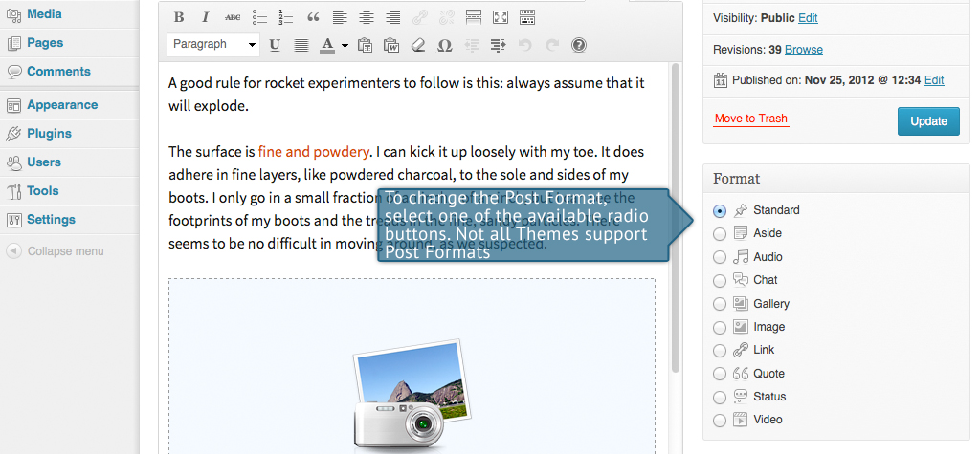

While the actual post content entry won't change, the theme can use the selected Format to display the post differently. How content is displayed is entirely up to the Theme, but the following list of available Post Formats provides some general WordPress guidelines as to how they might be styled.

* Aside – Typically styled without a title. Similar to a Facebook note update
* Audio – An audio file, such as a Podcast
* Chat – A chat transcript
* Gallery – A gallery of images. Post will likely contain a gallery [shortcode](http://codex.wordpress.org/Shortcode) and will have image attachments
* Image – A single image
* Link – A link to another site
* Quote – A quotation, most likely contained within a blockquote
* Status – A short status update, similar to a Twitter status update
* Video – A single video

## Reviewing Past Revisions

WordPress 3.6 sees some updates in the way you can review and restore past versions of your Posts and Pages.

When you’re editing your Post or Page, the number of revisions for that particular Post or Page is shown in the Publish Panel, if you have any.

Click the Browse link next to Revisions: in the Publish panel to browse through the various revisions for the current Post or Page.

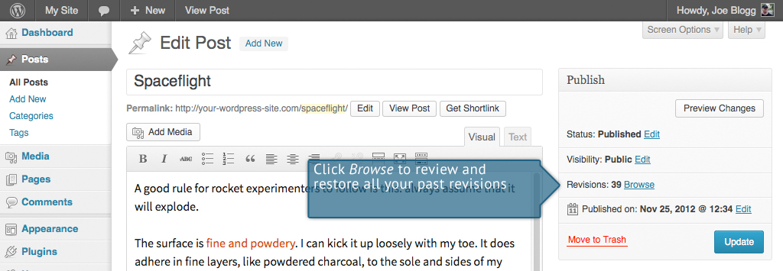

Use the slider at the top of the page or click the Previous and Next buttons to navigate through your various Post or Page revisions.

Content that has been deleted will be shaded red and content that has been added will be shaded green. If there is content that is shaded dark red and/or dark green, it’s highlighting specific content that was removed or added. If the paragraph or line is simply light red and/or light green, then the whole paragraph or line was affected by the change.

You can also compare two different revisions by clicking the Compare any two revisions checkbox at the top of the page.

If you’d like to restore a previous revision, click the Restore This Revision button.

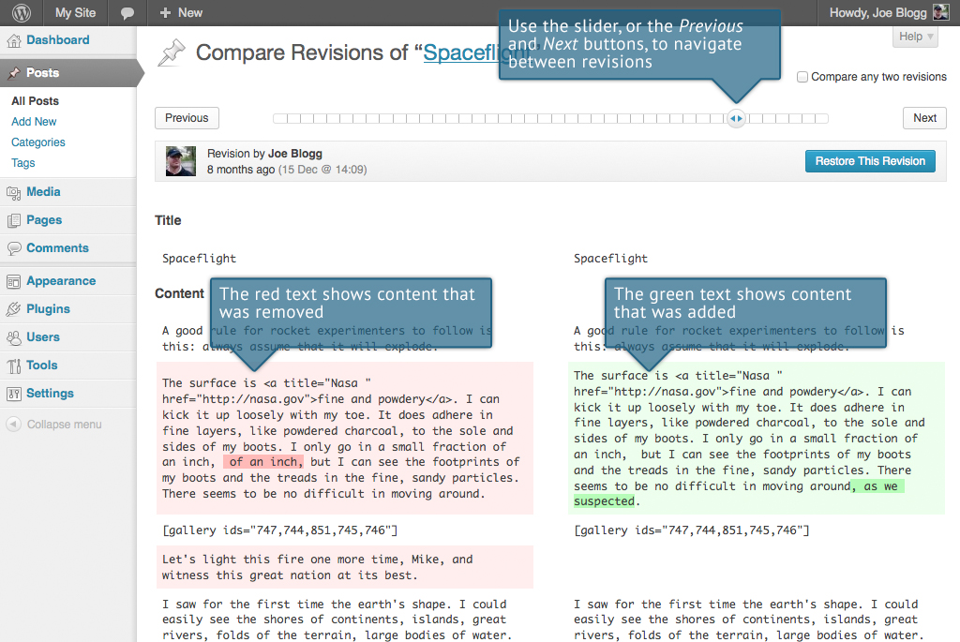

Adding Images and Other Media

Adding images and other media files such as videos, documents or PDFs is extremely easy within WordPress. All your images and files are stored in the Media Library. Once they’re uploaded into the Media Library, it’s a very simple matter to insert them into your Page or Post content. In the case of files such as Word Documents or PDFs, if necessary, it’s a simple process to create links to those files so that people can then download them.

## Inserting an Image

Adding media to your Pages or Posts has been made even easier from WordPress 3.5 onwards. Using a completely updated media manager it’s now extremely simple to insert, align and link your individual images and image galleries.

To insert an image into your Page/Post, click the Add Media button () and then simply drag your image(s) from wherever they are on your computer, into the browser window. Your file(s) will be automatically uploaded.

Alternatively, click the Select Files button and then select the file(s) that you’d like to upload, using the dialog window that is displayed.

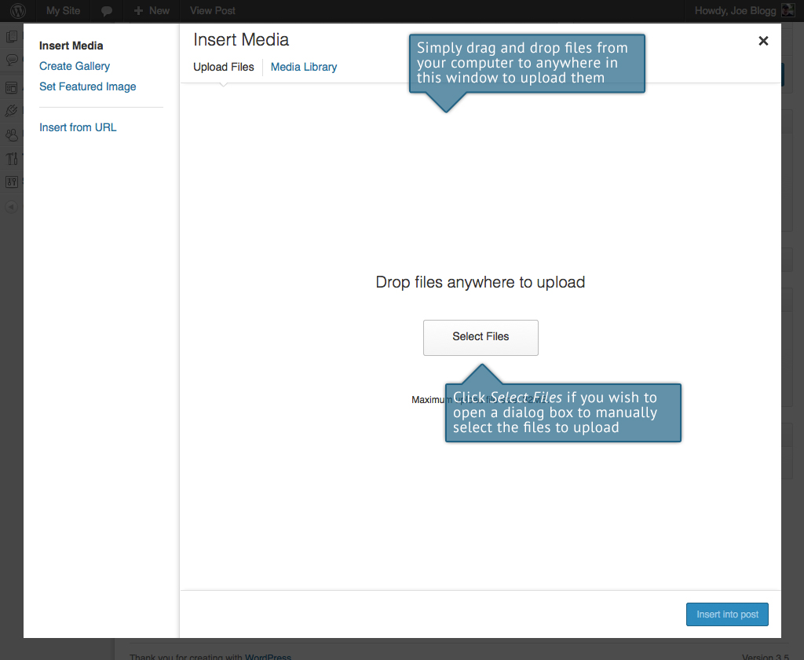

Once your image is uploaded, your Media Library, which contains all your previously uploaded images, is displayed. The image(s) that you’ve just uploaded will be automatically ‘selected’ for easy insertion into your Page or Post. Selected images are shown with a ‘tick’ icon in the top right corner of the image.

After uploading your image(s), you can then select other previously uploaded images by holding down the Ctrl key (Cmd key on Macs) and simply clicking on them. To deselect an image, click the ‘tick’ in the top right corner of the image.

At the bottom of the window you will see a count of the number of images currently selected.

There are several options within this Insert Media window to help make it easier to add images into your Page or Post.

By default, all previously uploaded images are shown, starting with the most recent uploads. If you’d like to narrow this list down, at the top of the window is a dropdown list that allows you to filter your displayed images by All media items, items Uploaded to this post, or just Images, Audio files or Video files. There is also a Search field that allows you to search for specific images.

The properties of the currently highlighted image (i.e. The image with the blue border) will be shown on the right-hand side of the Insert Media window. These properties include the filename, the date the file was uploaded and the image size. It’s at this point you can also change the image Title, Caption, [Alt Text](http://en.wikipedia.org/wiki/Alternate_text) and Description for each image, as well as the Alignment, Link and the Size at which the image is inserted.

* Title – is displayed as a tooltip when the mouse cursor hovers over the image in the browser
* Caption – is displayed underneath the image as a short description. How this displays will be dependent on the WordPress theme in use at the time. You can also include basic HTML in your captions
* Alt Text – is displayed when the browser can’t render the image. It’s also used by screen readers for visually impaired users so it’s important to fill out this field with a description of the image. To a small degree, it also plays a part in your website Search Engine Optimisation (SEO). Since search engines can’t ‘read’ images they rely on the Alt Text
* Description – is usually displayed on the attachment page for the media, however this is entirely up to the theme that is currently in use

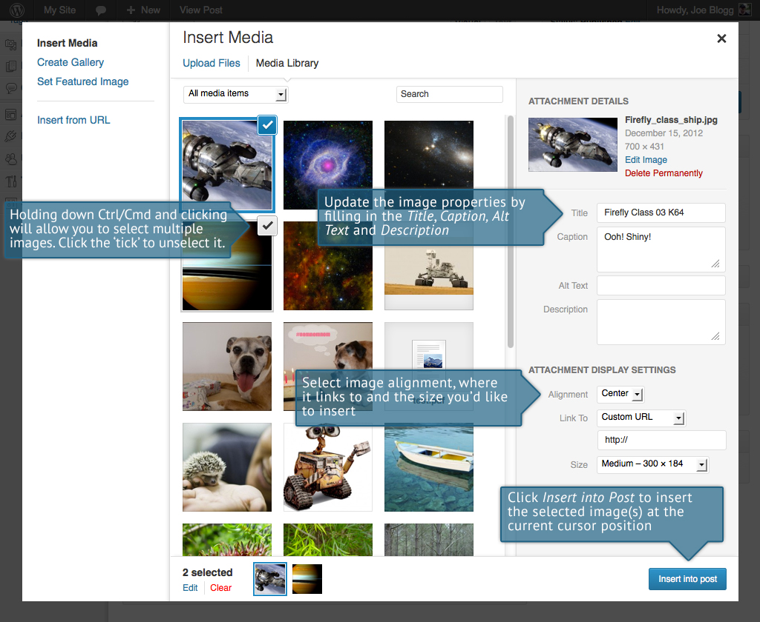

For each image, you can select how you would like the image aligned, either Left, Center or Right aligned, using the Alignment dropdown list. You can also select None for no alignment which will mean the image will display using the default alignment setting for your Theme.

You can also change what your inserted image(s) will link to using the Link To dropdown list. You have the choice of linking to the image’s attachment page by selecting Attachment Page, or you can link to the full size image by selecting Media File. You can also link to any URL by selecting Custom URL. When you do this, a new field will appear that allows you to enter in the custom URL. You can also choose not to link to anything by selecting None.

When your image(s) are uploaded, WordPress will also create several copies of your file at various sizes. You can choose which one you’d like to insert into your Page or Post using the Size dropdown list. To insert the image at the exact size you uploaded, simply select Full Size. Next to each size listed in this dropdown will be the actual dimensions of the image, in pixels (e.g. 300 x 184).

Once you’ve selected all your images, click the Insert into post button to insert the selected image(s) into your Post at the current cursor position (when editing a Page, this button will say Insert into page).

If you’d like to change the order of your images, click the Edit link at the bottom of the Insert Media window. The window will change so that only the selected images are shown. Alternatively, clicking the Clear link will deselect all images.

After clicking the Edit link at the bottom of the Insert Media window, all the currently selected images are shown. You can change the order in which the images will appear in your Page or Post by clicking and dragging each image to reorder them. You can also update the image Title, Caption, [Alt Text](http://en.wikipedia.org/wiki/Alternate_text) and Description for each image.

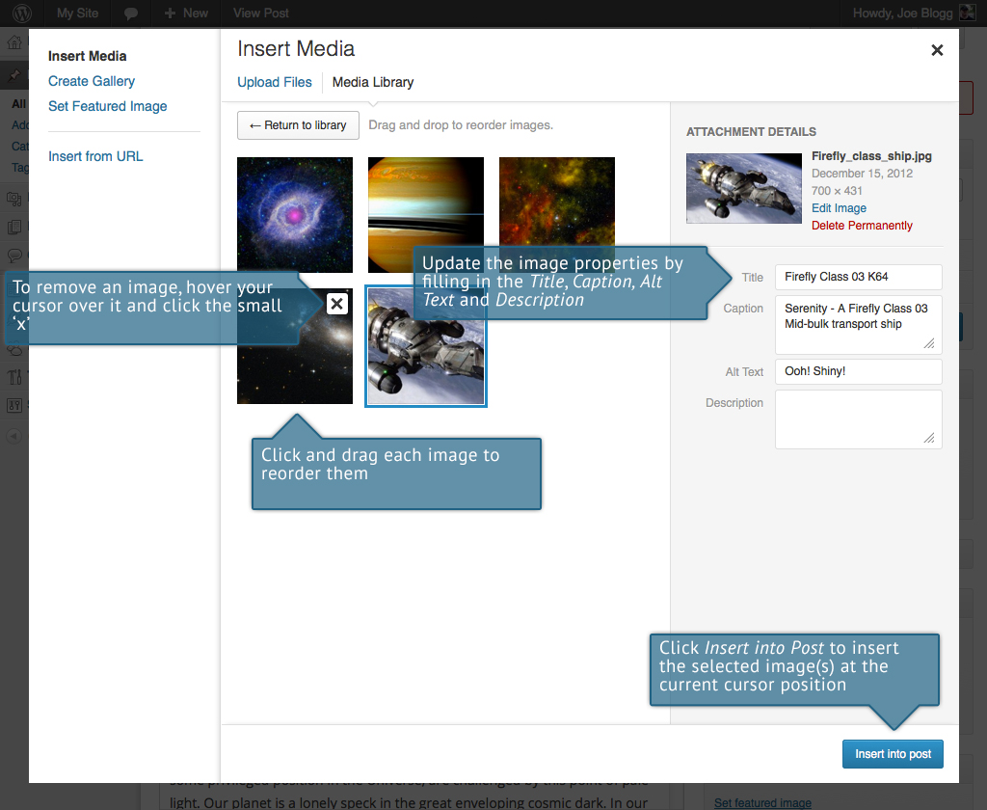

Clicking the Return to library button will take you back to the previous screen that allows you to select or deselect your images.

When you’re editing your Post/Page, if you wish to insert an image that you uploaded earlier (as opposed to uploading a new image), click the Add Media button again (). Once the popup window displays, click the Media Library link at the top of the pop-up window rather than dragging a new file into the upload window. All your previously uploaded images will be displayed, with the most recent ones shown first.

Select the image(s) that you’d like to insert into your Page or Post and then simply click the Insert into post button. As mentioned earlier, you can also click the Edit link at the bottom of the window if you’d like to change the order the images are inserted.

## Edit or Delete an Image

There are various options available for adjusting the layout of inserted images.

After clicking on an image that has already been inserted into your Page or Post, two icons will appear over the image. Clicking the left icon () allows you to edit the image properties. Clicking the right icon () will delete the image from your content. It will only remove the image from your Page or Post, it will not delete the image from your Media Library.

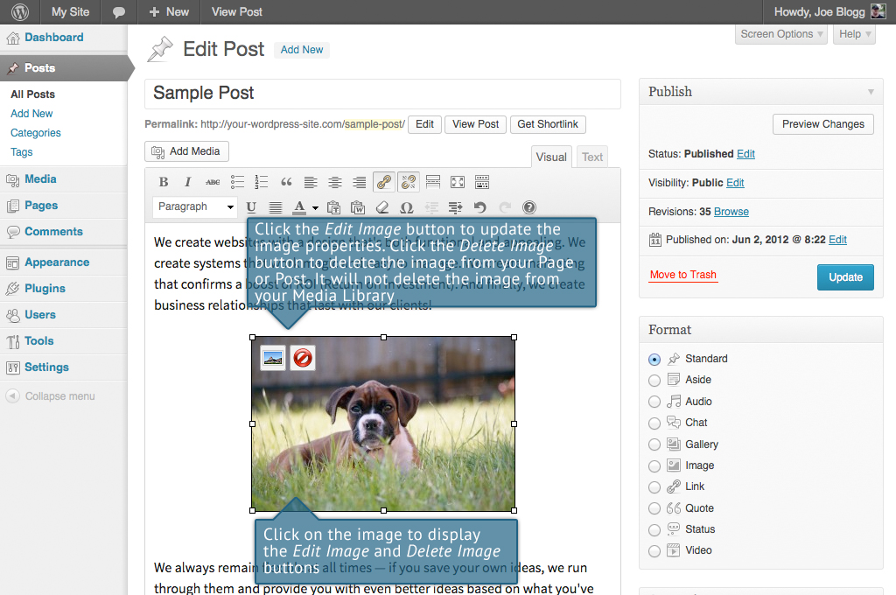

After clicking the Edit Image icon () the following pop-up window will appear.

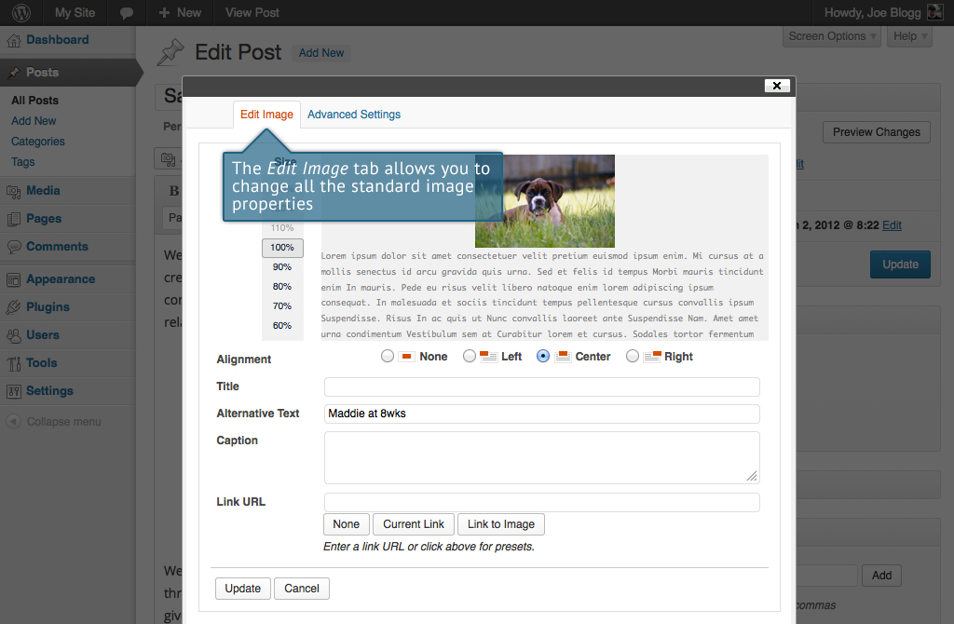

There are two tabs at the top of the pop-up window that contain the various image and link properties. The Edit Image tab allows you to change the following settings:

* Size – The size ‘slider’ displayed next to the image allows you adjust the image size. Sizes range from 130% down to 60%. If you want the image to be displayed at the same size that you inserted, then set this slider to 100%
* Alignment – Allows you to select how you would like the image aligned. They can be either Left, Centered or Right aligned. Setting alignment to None will remove the other alignment settings. How this affects your image within your content will depend on the current theme in use
* Title – is displayed as a tooltip when the mouse cursor hovers over the image in the browser
* Alternative Text – is displayed when the browser can’t render the image. It’s also used by screen readers for visually impaired users so it’s important to fill out this field with a description of the image. To a small degree, it also plays a part in your website Search Engine Optimisation (SEO). Since search engines can’t ‘read’ images they rely on the Alt Text
* Caption – is displayed underneath the image as a short description. How this displays will be dependent on the WordPress theme in use at the time. You can also include basic HTML in your captions
* Link URL – is the URL that the image links to. Leaving this field blank will mean the image will not have an HTML link assigned to it and will therefore do nothing if the image is clicked. Clicking the None button will remove any link currently set in this field. Clicking the Current Link button will set the Link URL to the default URL, if one is currently set for that image. The Link to Image button will use the URL of the actual image.

Once you have updated the image properties, click the Update button to save your changes. Alternatively, click Cancel to close the pop-up window without saving any changes.

Clicking on the Advanced Settings tab at the top of the above pop-up window allows extra image and link properties to be set. If you’re not familiar with HTML and CSS then it’s best to leave these settings alone.

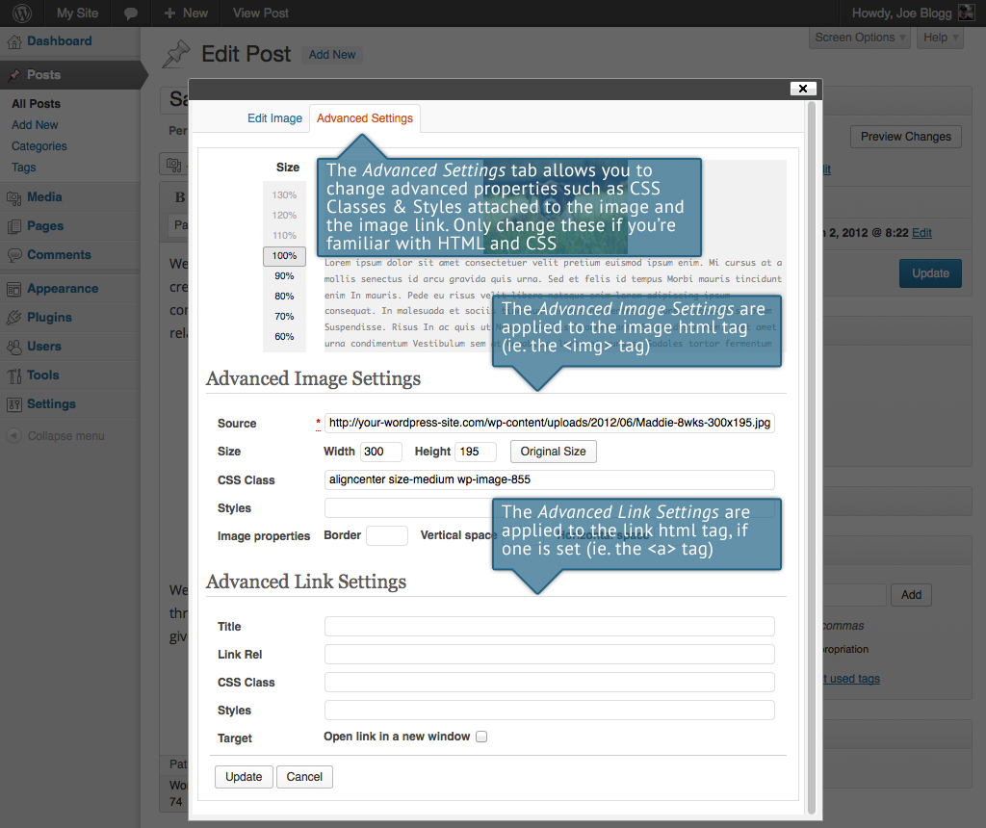

The Advanced Settings tab allows you to change the following settings.

The Advanced Image Settings change the html tag for the actual image (i.e. the <img> tag):

* Size – The size ‘slider’ displayed next to the image allows you adjust the image size. Sizes range from 130% down to 60%. If you want the image to be displayed at the same size that you uploaded, then set this slider to 100%
* Source – is the actual source location of the image. This should not be changed! If you need to changed the image then it’s best to delete the current image from the post and then reinsert the correct image from the Media Library
* Size Width/Height – These two input fields allow you specifically set the size to display your image. Care needs to taken when changing these values as it will distort your image if they aren’t changed proportionally. Clicking the Original Size button will return the width and height back to their original sizes
* CSS Class – By default, WordPress will assign several CSS Classes to your image. If, for some reason, there’s other CSS Classes that you’d like to assign to your image then you can add them into this input field
* Styles – is used to specify ad-hoc CSS styles for your image. These are applied as inline styles using the style attribute
* Image properties - Border – is used to specify the border width (in px) to display around the image. After changing the value in this field the Styles input field will be updated with the appropriate CSS style
* Image properties - Vertical space – is used to specify the margin (in px) above and below the image. After changing the value in this field the Styles input field will be updated with the appropriate CSS style
* Image properties - Horizontal space – is used to specify the margin (in px) on the left and right of the image. After changing the value in this field the Styles input field will be updated with the appropriate CSS style

The Advanced Link Settings change the html link tag assigned to the image, if one is currently set (i.e. the <a> tag):

* Title – is displayed as a tooltip when the mouse cursor hovers over the image in the browser
* Link Rel – describes the relationship from the current document to the specified link. More information on the rel HTML attribute can be found on [Wikipedia](http://en.wikipedia.org/wiki/Rel_attribute)
* CSS Class – If there is a specific CSS Class that needs to be set on the HTML link then you can add it into this input field
* Styles – is used to specify ad-hoc CSS styles for your link. These are applied as inline styles using the style attribute
* Target - Open link in a new window – When someone clicks the image link you can have it open in the same window (default setting) or, if this box is checked, have it open in a new browser window/tab

Once you have updated the image properties, Click the Update button to save your changes. Alternatively, click Cancel to close the pop-up window without saving any changes.

## Setting a Featured Image

Some themes allow you to specify a Featured Image for your Page and Post. A Featured Image, often called a Post/Page Thumbnail, is usually some sort of image that is representative for that particular Page or Post. How these images are displayed is dependent entirely on the Theme that is currently in use.

If your Theme allows you to set a Featured Image, the following Featured Image panel will be displayed when you’re editing your Page or Post. If Featured Images can’t be set then this panel won’t be displayed.

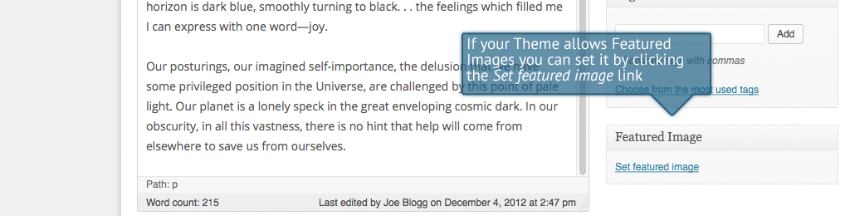

Setting your featured image is very similar to adding an image into your Page or Post. After clicking the Set featured image link a pop-up window will display that looks similar to the one that displays when you add an image to your Page/Post. You can upload a new image to use as your Featured Image or you can simply choose from one of your previously uploaded images.

By default, you’ll be shown a list of the previously uploaded images. If you’d like to upload a new image, click on the Upload Files link at the top of the pop-up window. After clicking the image you’d like to use as your featured image you can then update the Title, Caption, Alt Text and Description. To set the image as your Featured Image, click the Set featured image button. Your chosen image will then appear in the Featured Image panel.

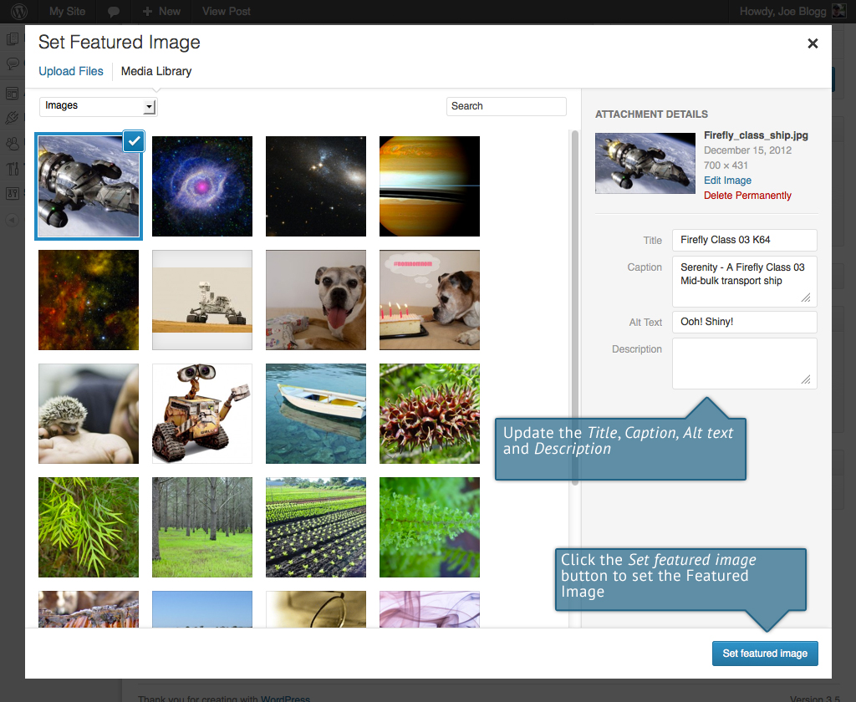

## Insert an Image Gallery

WordPress has its own simple built-in Image Gallery that allows you to add multiple images to a page in one easy step.

To insert an image gallery into your Page/Post, click the Add Media button (). A pop-up window will display that looks the same as the one that displays when you add an image to your Page/Post. You can upload new images to use in your gallery or you can simply choose from your previously uploaded images.

By default, you’ll be shown a list of the previously uploaded images. If you’d like to upload a new image, click on the Upload Files link at the top of the pop-up window. Alternatively, click the Create Gallery link in the left hand navigation then select the images that you’d like to insert into your gallery.

After selecting your images, click the Create a new gallery button at the bottom of the pop-up window. The window will change so that only the selected images are shown.

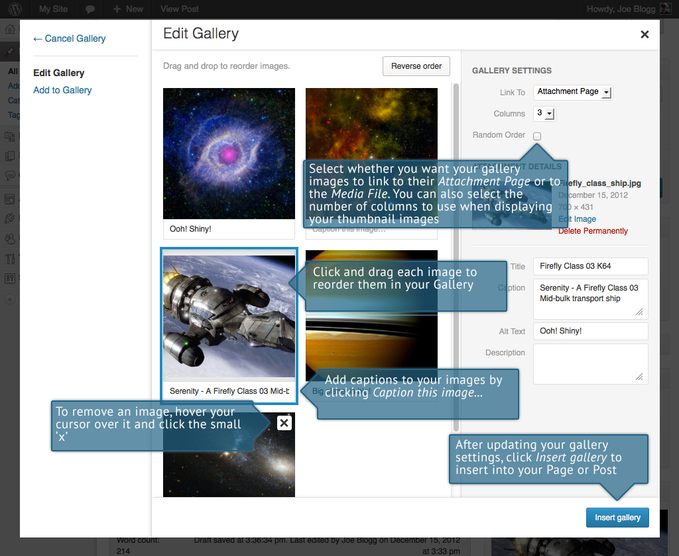

All the images that appear will be used within your Image Gallery. To reorder the images simply click on an image and drag it to its new position. If you’d like to add captions to your images, click the ‘Caption this image..’. text below each image and then type in your caption. Alternatively, click each image and then update the Title, Caption, Alt Text and Description on the right hand side of the pop-up window. You can also include basic HTML, such as links, in your captions.

If you decide you no longer want a certain image to appear in your gallery, click the small ‘x’ that appears in the top right corner of the image when you hover your cursor over it.

Since the built-in gallery is quite simple, there aren’t that many options to choose from when setting it up.

* Link to – This sets what happens when the thumbnail image is clicked. Selecting Media File will open the (full size) image directly in your browser window. Selecting Attachment Page will open the image within one of your WordPress formatted pages.
* Columns – Specifies the number of columns to use when displaying your thumbnail images. Ultimately, this will be dependent on your Theme and how wide your page is. If you find the gallery isn’t displaying properly after changing this number you may need to change it to another number.
* Random Order – Click this checkbox to display your images in a random order

## Edit or Delete an Image Gallery

Editing or Deleting an Image Gallery is much like editing or deleting an image. After clicking on an Image Gallery that has been inserted into your Page or Post, two icons will appear on top of the gallery. Clicking the left icon () allows you to edit the image gallery properties. Clicking the right icon () will delete the image gallery from your content. It will only remove the image gallery from your Page or Post, it will not delete any images from your Media Library.

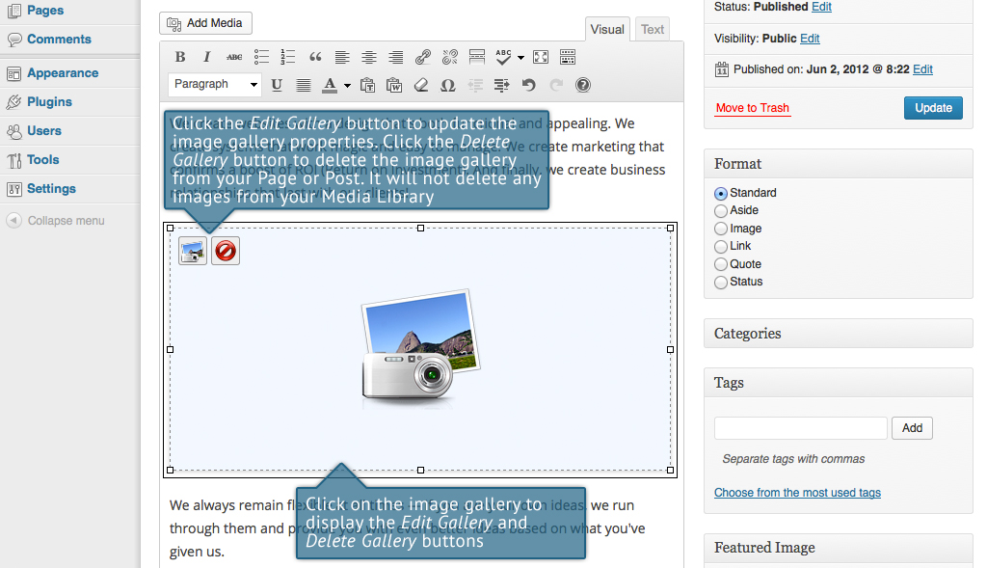

After clicking the Edit Gallery icon you will be shown the same pop-up window and options as when your image gallery was inserted into your Page/Post.

## Inserting Video, Audio or Other File Type

The procedure for inserting any other type of file into your Page/Post is exactly the same as Inserting an Image. Simply click the Add Media button (). Once the relevant popup window displays, perform the same steps to upload your file to your site and to insert it into your Page or Post.

When inserting video or audio files, you can select Embed Media Player from the Embed or Link dropdown list in the Insert Media pop-up window to use the new audio and video players that are now built into WordPress. Supported audio/video formats include M4a, MP4, OGG, WebM, FLV, WMV, MP3, WAV and WMA files.

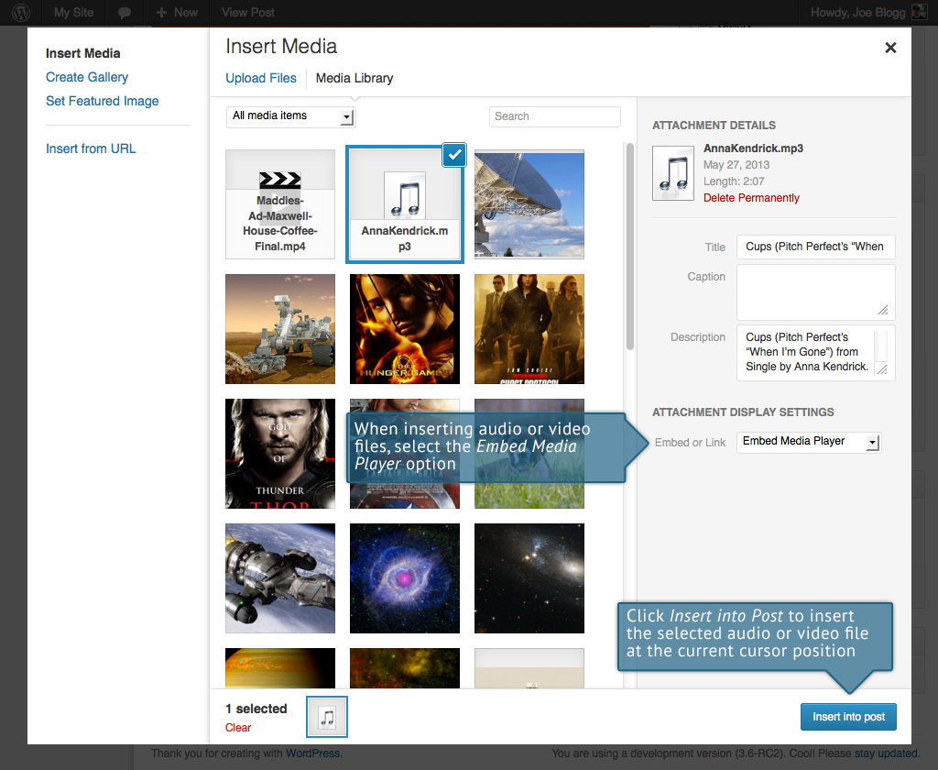

|  |  |
| --- | --- |
|  | It’s recommended that you make your filename ‘server friendly’. Make sure the filename has no spaces, apostrophes, slashes or other non-alphanumeric characters (such as $, % and &). Rename the file before uploading if it does. To preserve readability, some people replace spaces with the underline character or hyphen. For instance, My File Name.txt becomes My_File_Name.txt or My-File-Name.txt |

## Embedding a Video, Image or Other Content

Another way to add video or other content into your pages is through embedding. A popular example of this is embedding a YouTube video into your page.

When you’re embedding a file, there’s no need to upload the file to your site. You’re basically just creating a link to the file, from within your own page. WordPress is able to automatically embed files from a number of different services.

To embed something into your Post or Page, simply paste the URL into your content area. The URL needs to be on its own line and not hyperlinked.

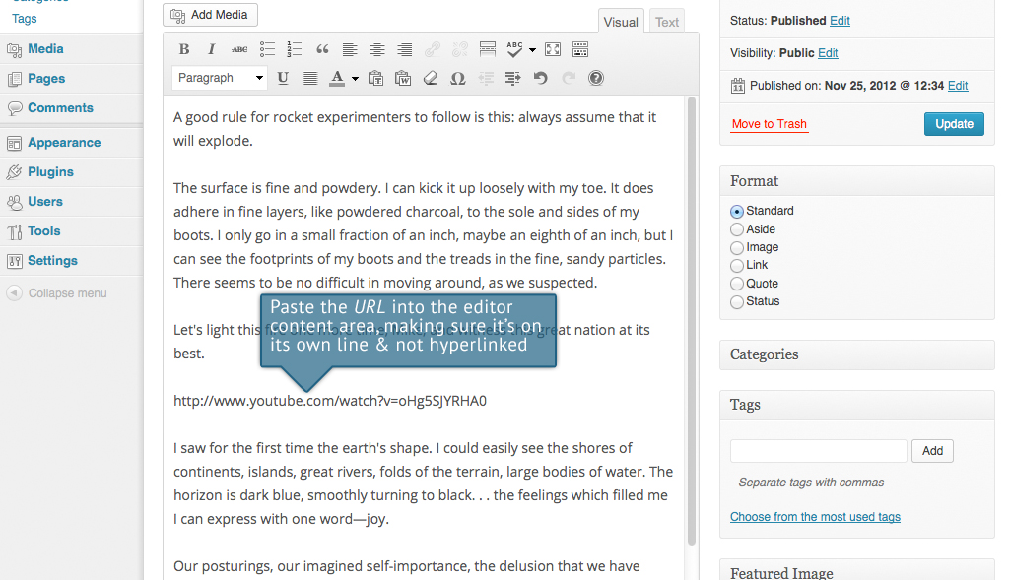

If you’d like to specify the width and height, you can wrap the URL in the [embed] [shortcode](http://codex.wordpress.org/Shortcode_API). Embedding your link using this shortcode does not require the URL to be on its own line. The format for using the shortcode is:

[embed width= “123” height= “456”] url [/embed]

WordPress will automatically embed content from the following sites:

* [YouTube](http://www.youtube.com/) (Only public videos)
* [Vimeo](http://vimeo.com/)
* [DailyMotion](http://www.dailymotion.com/)
* [blip.tv](http://blip.tv/)
* [Flickr](http://www.flickr.com/)
* [Viddler](http://www.viddler.com/)
* [Hulu](http://www.hulu.com/)
* [Qik](http://qik.com/)
* [Revision3](http://revision3.com/)
* [Scribd](http://www.scribd.com/)
* [Photobucket](http://photobucket.com/)
* [Polldaddy](http://www.polldaddy.com/)
* [WordPress.tv](http://wordpress.tv/) (Currently only VideoPress type videos)
* [SmugMug](http://www.smugmug.com/)
* [FunnyOrDie.com](http://www.funnyordie.com/)
* [Twitter](https://twitter.com/)
* [Instagram](http://instagram.com/)
* [SlideShare](http://www.slideshare.net)
* [SoundCloud](http://soundcloud.com/)
* [Rdio](http://www.rdio.com)
* [Spotify](https://www.spotify.com)

Adding HTML Links

HTML links allow your site visitors to easily navigate around your site. They’re also used when you want to allow people to download files from your site, such as PDFs or other documents, for viewing images or even just linking to other websites. HTML links will frequently be shown with an underline to differentiate it from other text, but this may vary depending on the theme you’re currently using.

## Inserting an HTML Link

Inserting an html link in your Page/Post to one of your own pages or another site is extremely easy. Simply click and drag the cursor and highlight the text that you want turned into a link and then click the Insert/edit link button (). As well as being able to insert a link to another site, you can also easily insert a link to one of your existing Posts or Pages by simply selecting it from a list.

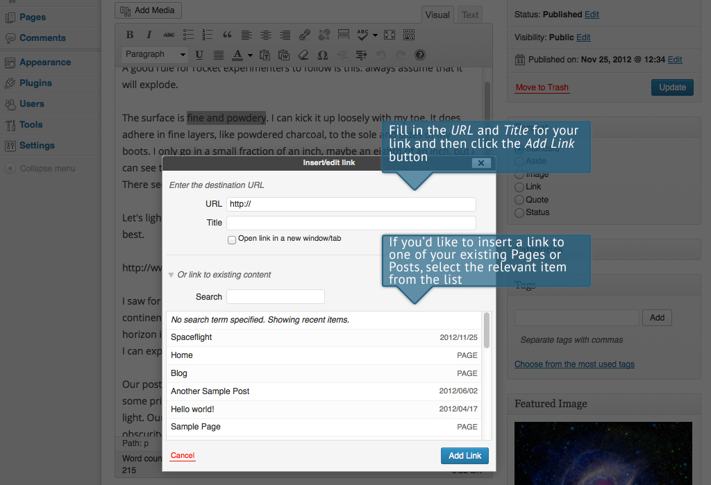

In the popup window that is displayed, simply fill in URL and the Title and then click the Add Link button.

* URL – URL of the page or website that you would like to create a link to
* Title – The text to display in tooltip form when the cursor hovers over the link
* Open link in a new window/tab – When someone clicks the link you can have it open in the same window (default setting) or have it open in a new browser window/tab

Alternatively, if you’d like to add a link to one of your existing Posts or Pages, simply click the Or link to existing content link to display a list of your existing content then select the relevant page from the supplied list. If you have a large number of pages within your site, you can type the Page or Post name in the Search field to make it easier to find. As you type, the list will re-populate based on matching results. After selecting one of your existing pages, the relevant details will be updated in the URL and Title fields. Click the Add Link button to add your link.

## Editing an HTML Link

Simply click the link within your Page/Post that you’d like to edit, to position the cursor somewhere within it and then click the Insert/edit link button (). A popup window will appear, just like when the link was originally inserted. Update the required details and click the Update button.

## Removing an HTML Link

To remove an html link, click the link within your post that you’d like to remove, to position the cursor somewhere within it and then click the Unlink button (). If you want to remove a link from an image, simply click the image once to select it and then click the Unlink button. If the html link is linking to an uploaded file or image, clicking the Unlink button won’t remove or delete that file, it will simply remove the hyperlink.Editing Existing Content

To edit an existing page, simply click on the relevant Page/Post title, when viewing your list of Pages or Posts. Alternatively, click on the Edit link that appears beneath the title when hovering your cursor over each row.

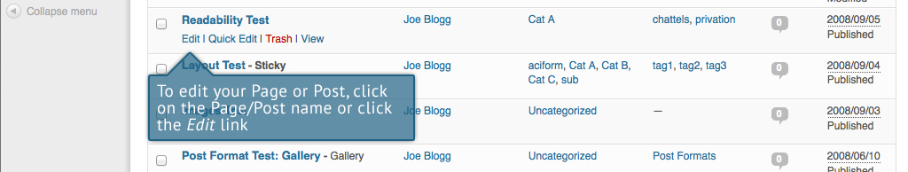

The screen that appears will be exactly the same as the Add New Page/Add New Post screen, only with the existing content displayed. When you’ve finished editing your Page/Post, click the Update button.

Deleting Content

If you wish to delete one of your Pages or Posts, click on the Trash link that appears beneath the title when hovering your cursor over each row. This will move the Page/Post to the Trash.

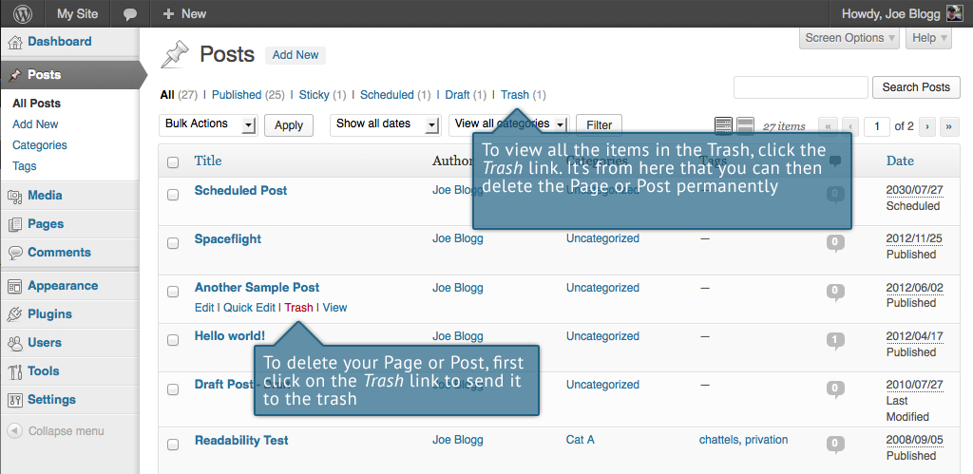

To delete the Page/Post permanently or to restore the Page/Post, click the Trash link at the top of the screen. When the cursor is hovering over each item in the Trash, the Restore and Delete Permanently links appear. Click Delete Permanently to permanently remove a single Page or Post. Clicking Restore will restore the Page or Post.

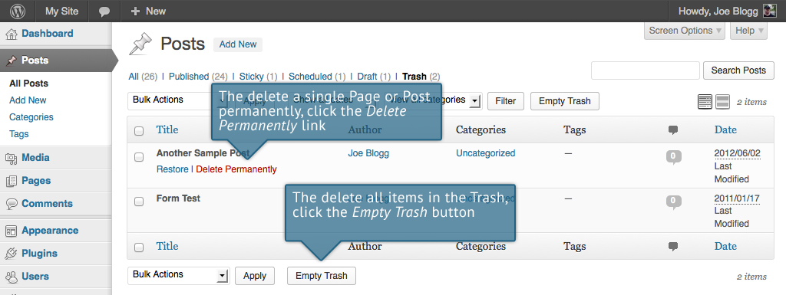

If you would like to permanently delete or restore numerous items at once, click the checkboxes next to the items you would like to delete or restore and then choose either Restore or Delete Permanently from the Bulk Actions dropdown list at the top of the page. After selecting the appropriate action click the Apply button to make your change. Alternatively, click the Empty Trash button to delete all the items in the Trash.

Fullscreen Editing

WordPress allows for fullscreen composing. It provides for complete distraction free editing of your Page or Post. To enter fullscreen mode simply click on the Toggle fullscreen mode button (). The editor will then takeover the whole browser window.

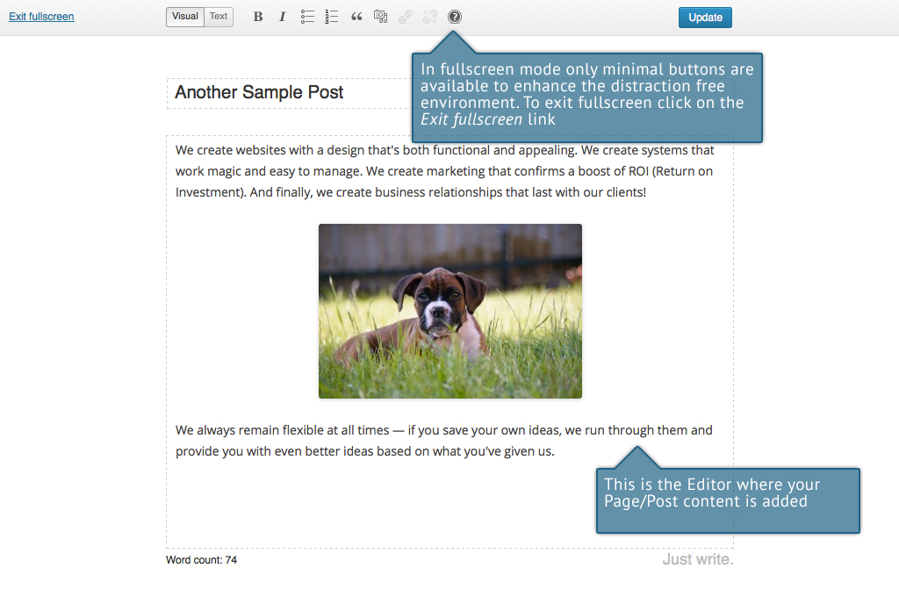

At the top of the screen is a toolbar with only the minimal number of buttons to enhance the distraction free environment. The toolbar and editor borders are displayed when first entering fullscreen mode. After a few seconds, these fade leaving you with a clean and clutter free editor where you can concentrate on updating your content.

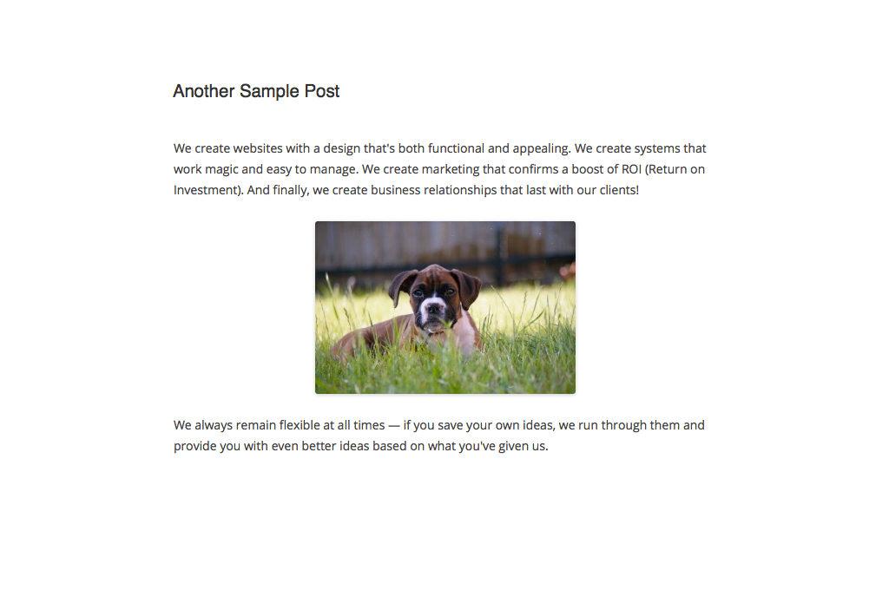

To view the menu toolbar again once they have faded simply move your cursor up towards the top of the screen and they will be displayed again.

To exit from fullscreen mode and return to the standard visual editor, click on the Exit fullscreen link at the top of the page.

Saving and Publishing Content

Once you’ve added all your content to your Page or Post you have the option of Saving the Page as a Draft or Publishing the page. Clicking the Save Draft button will simply save your Page/Post. This is handy if you would like to come back at a later date to add more content or if you’re simply not ready to publish yet.

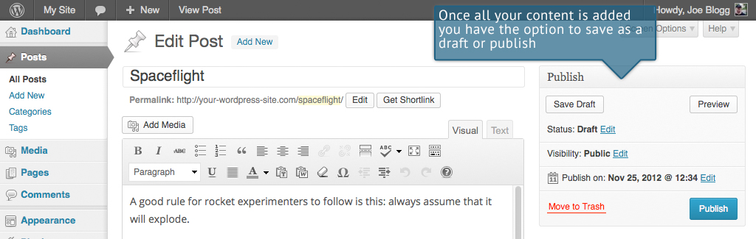

Clicking the Publish button will save your Page/Post and publish it on your website.

Clicking the Preview button will show you a preview of the current Page/Post.

There are also several options available when saving. By default the Status is set to Draft but this can be changed by clicking the Edit link just to the right of Status: within the Publish panel.

* Pending Review means the draft is waiting for review by an editor prior to publication.
* Draft means the post has not been published and remains a draft for you.

You can also change the visibility of the Page by clicking the Edit link just to the right of Visibility: within the Publish panel.

* Public is the default and means the page is viewable to all. There is also an option to make the Post ‘sticky’. Sticky posts are placed at the top of all blog posts and stay there even after new posts are published.
* Password Protected allows you to assign a password to your page. Only people who have the password will be able to access the page.
* Private hides the content from the public completely. Normal users and visitors will not be aware of private content. You will only see the private content when you are logged into your WordPress blog.

By default, when you click the Publish button your Page/Post is published immediately. To change this, click the Edit link just to the right of Publish on: within the Publish panel. You can then select the date and time that you’d like to schedule your Page/Post to be published. You must also click the Publish button when you have updated the date and time fields to publish at the desired date and time.

Categories

You can use categories to define sections of your site and group related posts. The default category is Uncategorized but this can be easily changed in your Settings. Pages cannot be associated with Categories. You can only associate Categories to Posts.

There are two ways to add Categories. They can be added whilst adding or editing your Post or they can be added via the Categories menu option. Adding Categories whilst editing your Post, will automatically assign those Categories to your Post. Adding Categories using the Categories menu option will simply add them to the list of available Categories.

When you click on the Categories menu option you’ll be shown a list of Categories that have already been added along with some blank fields that allow you to add a new Category.

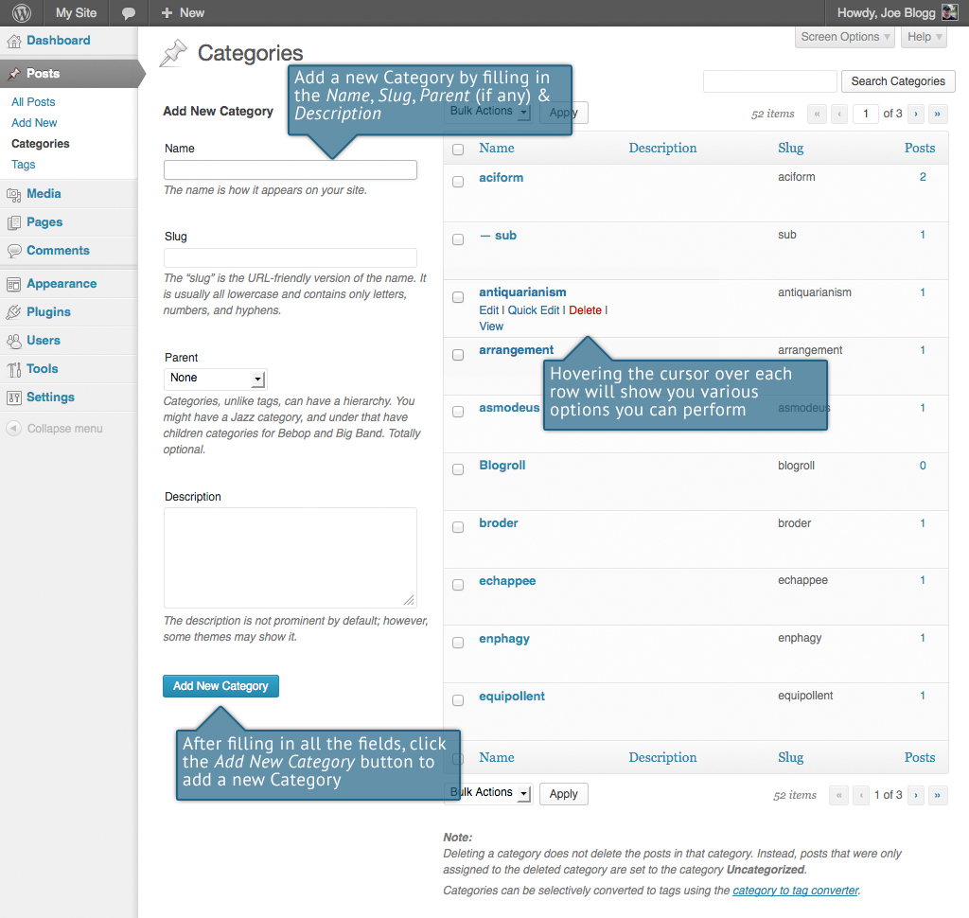

To add a new Category, fill in the blank fields and then click the Add New Category button:

* Name – The name is how it appears on your site
* Slug – The Slug is the URL-friendly version of the name. It’s usually all lowercase and contains only letters, numbers, and hyphens
* Parent – Categories, unlike tags, can have a hierarchy. You might have a Car category, and under that have children categories for Ford, General Motors and Toyota. Totally optional. To create a subcategory, just choose another category from the Parent dropdown.
* Description – The description is not prominent by default; however, some themes may display it

Once you add a new Category it will appear in the list of Categories on the right side of the screen.

When hovering your cursor over each row in the list of Categories, a few links will appear beneath the Category name.

* Edit – Allows you to edit the Category properties such as Name, Slug, Parent and Description
* Quick Edit – Allows you to quickly edit the Category Name and Slug
* Delete – Deletes the Category permanently from the list of Categories. After clicking Delete you will be prompted to confirm your choice. Click OK to delete the Category or Cancel if you don’t want to delete it.
* View – This will list all the Posts that are currently using this Category

If you would like to permanently delete numerous Categories at once, click the checkboxes next to the Categories you would like to delete and then choose Delete from the Bulk Actions dropdown list at the top of the page. After selecting Delete, click the Apply button to immediately delete the selected Categories (you will not be prompted to confirm your choice).

Deleting a Category does not delete the posts in that Category. Instead, posts that were only assigned to the deleted Category are set to the default Category, which is set to Uncategorized by default. The Default Post Category can be configured within the Settings > Writing section.

## Adding Categories within your Post

Adding Categories whilst editing your Post will automatically assign those Categories to your Post.

When adding or editing your Post, the Categories panel can be found just below the Format panel if your Theme supports Post Formats. Alternatively, it will reside just below the Publish panel. To add an existing Category, simply tick the checkbox(es) next to the Categories you’d like to assign to the Post.

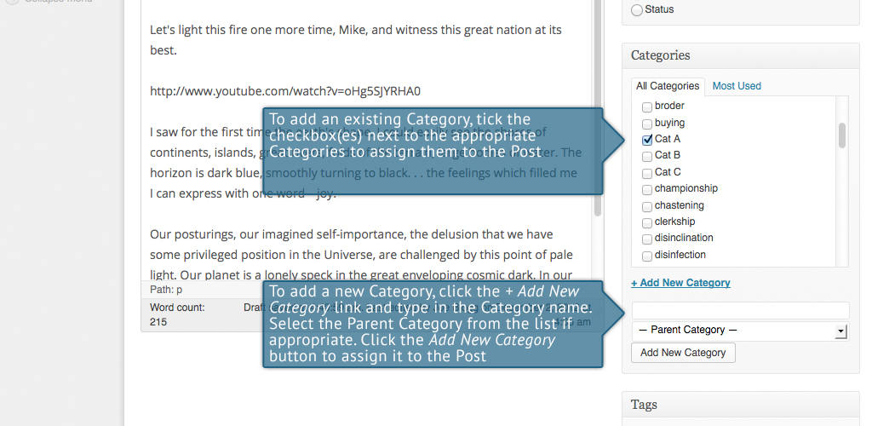

If you would like to create a new Category and assign it to the Post at the same time, click the + Add New Category link. Two fields will then appear. Type the name of the Category that you’d like to add into the empty input field. If you’d like the new Category to have a Parent, select it from the Parent Category dropdown list. Click the Add New Category button when done to create the Category and automatically assign it to the Post.

Tags

Tags are ad-hoc keywords that identify important information in your post (names, subjects, etc) that may or may not recur in other posts. Unlike Categories, Tags have no hierarchy, meaning there’s no relationship from one Tag to another. Pages cannot be assigned Tags and cannot be associated with Categories. You can only associate Tags and Categories to Posts.

Like Categories, there are two ways to add Post Tags. They can be added whilst adding or editing your Post or they can be added via the Tags menu option. Adding Tags whilst editing your Post, will automatically assign those Tags to your Post. Adding Tags using the Tags menu option will simply add them to the list of available Tags.

When you click on the Tags menu option you’ll be shown a list of Tags that have already been added, along with some blank fields that allow you to add a new Tag. A list of popular Tags is also displayed in ‘cloud’ format. That is, the Tags are displayed in alphabetical order and the more often a Tag has been used, the larger the font it’s displayed in.

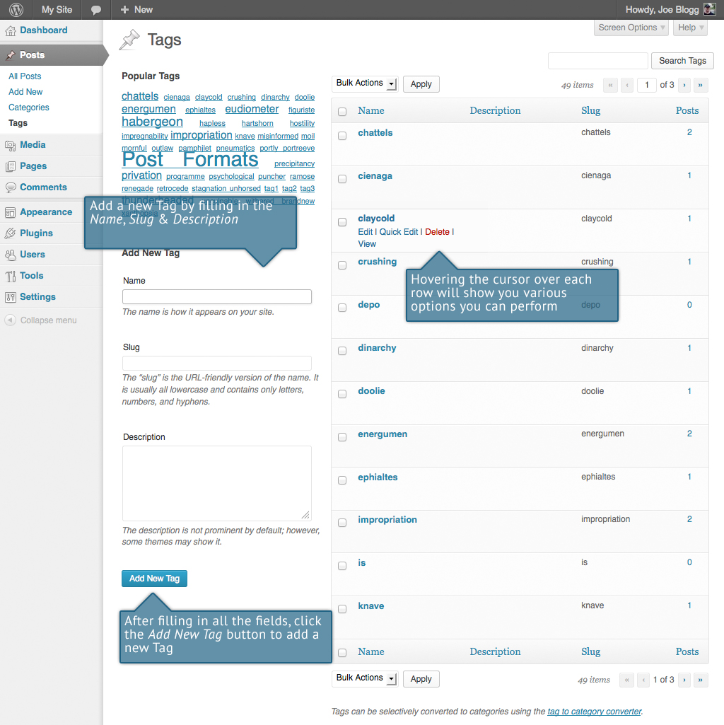

To add a new Tag, fill in the blank fields and then click the Add New Tag button:

* Name – The name is how it appears on your site
* Slug – The Slug is the URL-friendly version of the name. It’s usually all lowercase and contains only letters, numbers, and hyphens
* Description – The description is not prominent by default; however, some themes may display it

Once you add a new Tag it will appear in the list of Tags on the right side of the screen.

When hovering your cursor over each row in the list of Tags, a few links will appear beneath the Tag name.

* Edit –Allows you to edit the Tag properties such as Name, Slug and Description
* Quick Edit – Allows you to quickly edit the Tag Name and Slug
* Delete – Deletes the Tag permanently from the list of Tags. After clicking Delete you will be prompted to confirm your choice. Click OK to delete the Tag or Cancel if you don’t want to delete it.
* View – This will list all the Posts that are currently using this Tag

If you would like to permanently delete numerous Tags at once, click the checkboxes next to the Tags you would like to delete and then choose Delete from the Bulk Actions dropdown list at the top of the page. After selecting Delete, click the Apply button to immediately delete the selected Tags (you will not be prompted to confirm your choice).

## Adding Tags within your Post

Adding Tags whilst editing your Post, will automatically assign those Tags to your Post.

When adding or editing your Post, the Tags panel can be found just below the Categories panel. To add an existing Tag, click the Choose from the most used tags link. This will display a list of previously used Tags (if available). They are arranged alphabetically and in ‘cloud’ format. That is, the more often a Tag has been used, the larger the font it’s displayed in. To add a previously used Tag, simply click on the Tag name and it will be assigned to your Post. To add a new Tag, simply write the Tag or Tags (separated with commas) into the edit field and click the Add button. Tags that are assigned to the Post will be displayed below the edit field. To remove a Tag from your Post, click the small ‘x’ icon next to the Tag name.

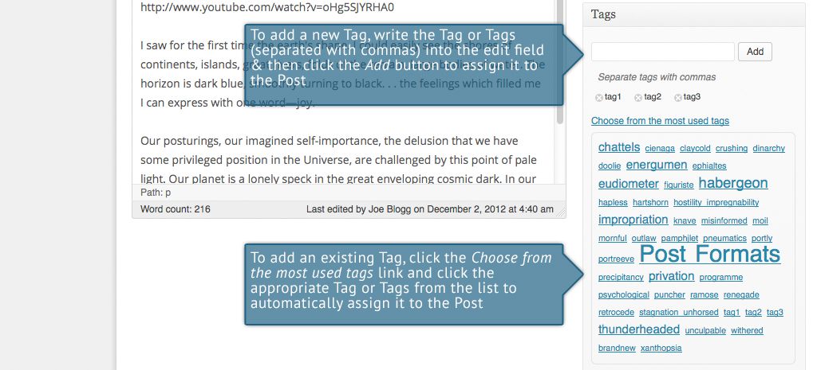

Media Library

The Media Library is where you can find all the files that you’ve uploaded. The most recent uploads are listed first. The list of files contains a small thumbnail version of the image or file, the file name and the type of file (jpg, txt, etc.), the name of the Author who uploaded the file, the Page or Post which the image was uploaded to, the number of comments and the date the file was uploaded.

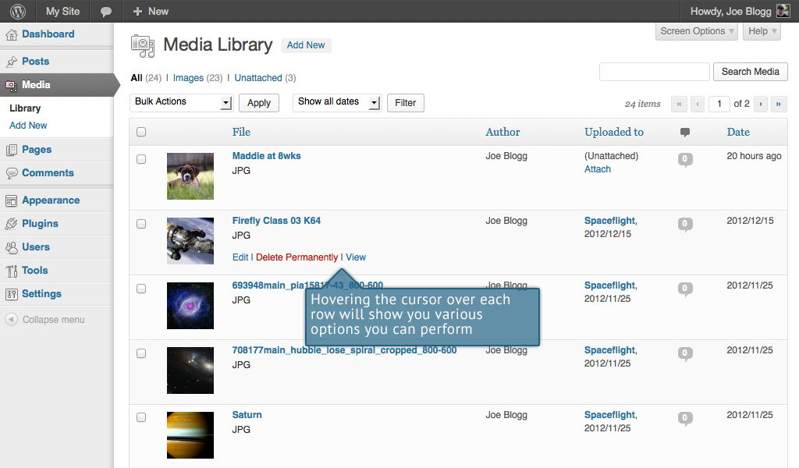

When hovering your cursor over each row, a few links will appear beneath the file name.

* Edit – Allows you to edit the file properties such as Title, Alt Text, Caption and Description. You can also perform some basic image manipulation
* Delete Permanently – Deletes the file permanently from the Media Library
* View – Will take you to the display page for that file

## Viewing a File in the Media Library

To view a file, hover the cursor over the particular row that contains the file name and click the View link. If the file is an image, you'll see a larger version of the image. If the file was another type of file such as a text file or PDF for example, you'll simply see a link to that file. Click the link to view the file.

## Adding a File to the Media Library

To add a new file to the Media Library, click on the Add New link in the left hand navigation menu or the Add New button at the top of the page. You will be presented with a page similar to the popup window that is displayed when uploading a new image in your Post or Page.

To upload a new file to the Media Library, simply drag your images from wherever they are on your computer, into the area marked Drop files here. Your file(s) will be automatically uploaded.

Alternatively, click the Select Files button and then select the files that you’d like to upload, using the dialog window that is displayed.

Once your images or files are uploaded, they’re listed below the file uploader. If you’d like to edit the file properties, click the Edit link next to the file.

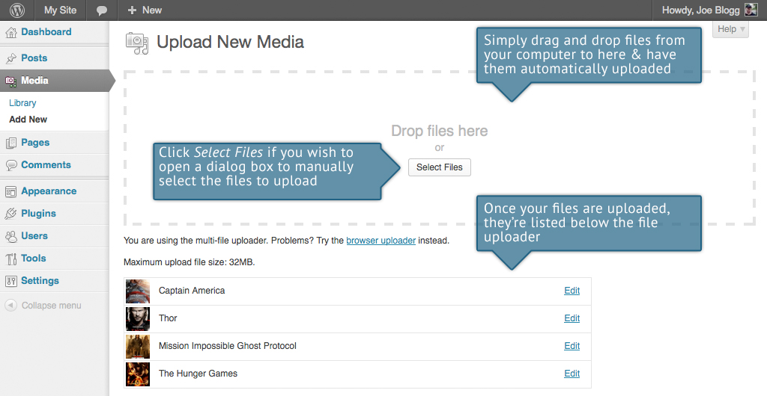

## Editing the File Properties

To edit the properties of an existing file, hover the cursor over the particular row that contains the file, when viewing the list of Media Library files and click the Edit link. Alternatively, you can also click the file title or the thumbnail image. Clicking the Edit link next to the file after it’s just been uploaded, will also allow you to edit its properties.

After clicking Edit, the file properties are displayed, including the title, URL, filename, file type and in the case of an image, the file dimensions. When editing the file properties, the Alternative Text field will only be displayed for images.

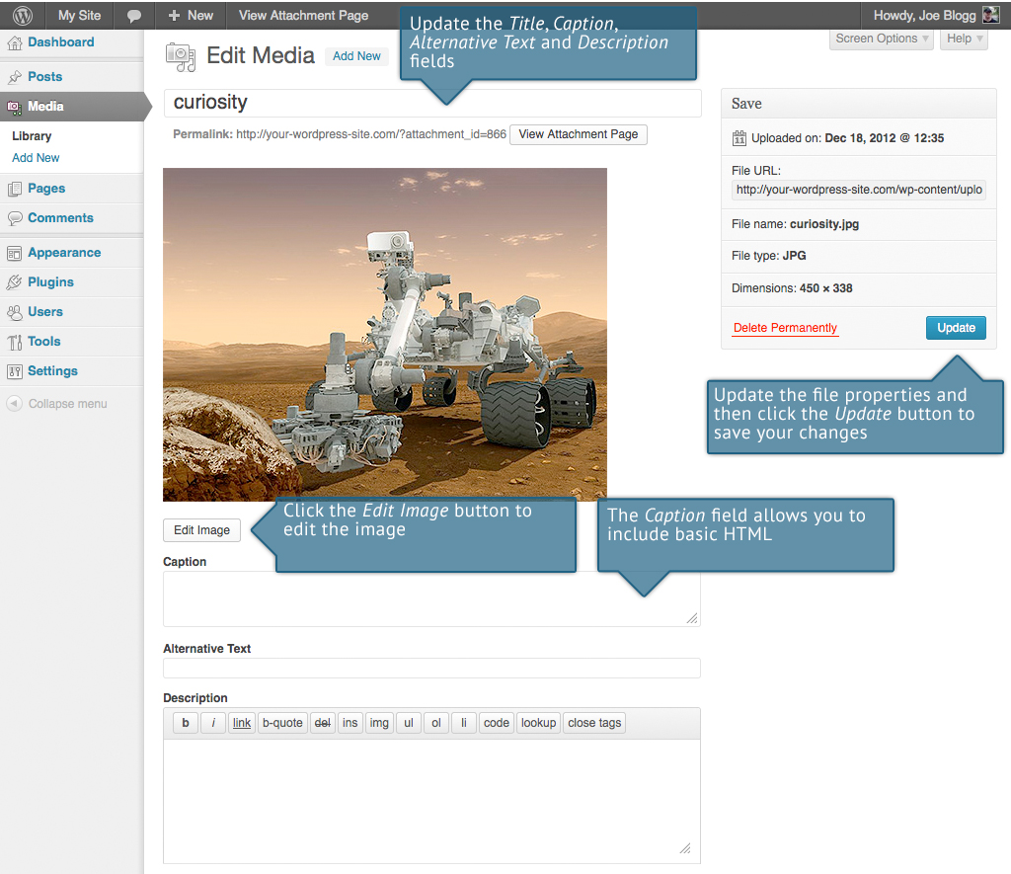

* Title – Although the field isn’t labelled, the Title is the field at the very top of the page. The Title is displayed as a tooltip when the mouse cursor hovers over the image in the browser
* Caption – is displayed underneath the image as a short description. How this displays will be dependent on the WordPress theme in use at the time. You can also include basic HTML in your captions
* Alternative Text – is displayed when the browser can’t render the image. It’s also used by screen readers for visually impaired users
* Description – This content is displayed on the file’s attachment page

Once the file properties are updated click the Update button to save your changes.

### Editing an Image

WordPress has a basic image editing tool that allows you to perform some simple manipulation with your uploaded images. You’re able to rotate and flip your images as well as scale them and crop them to different sizes.

When editing the properties of an image (as opposed to other file types like documents or PDFs), click the Edit Image button just below the thumbnail to show the image editing tools.

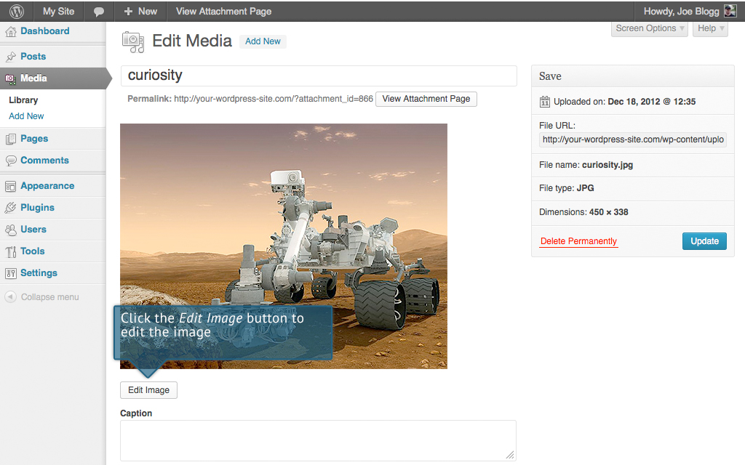

Just above the image you’ll find the following image editing buttons:

|  |  |
| --- | --- |
|  | Crop – Click on the image and drag the selection box to the size that you’d like the image cropped. Click the Crop button to crop the image to the new size |
|  | Rotate counter-clockwise – Rotate the image 90° counter-clockwise |
|  | Rotate clockwise – Rotate the image 90° clockwise |
|  | Flip vertically – Flip the image vertically |
|  | Flip horizontally – Flip the image horizontally |
|  | Undo – Undo the last change |
|  | Redo – Redo the last change |

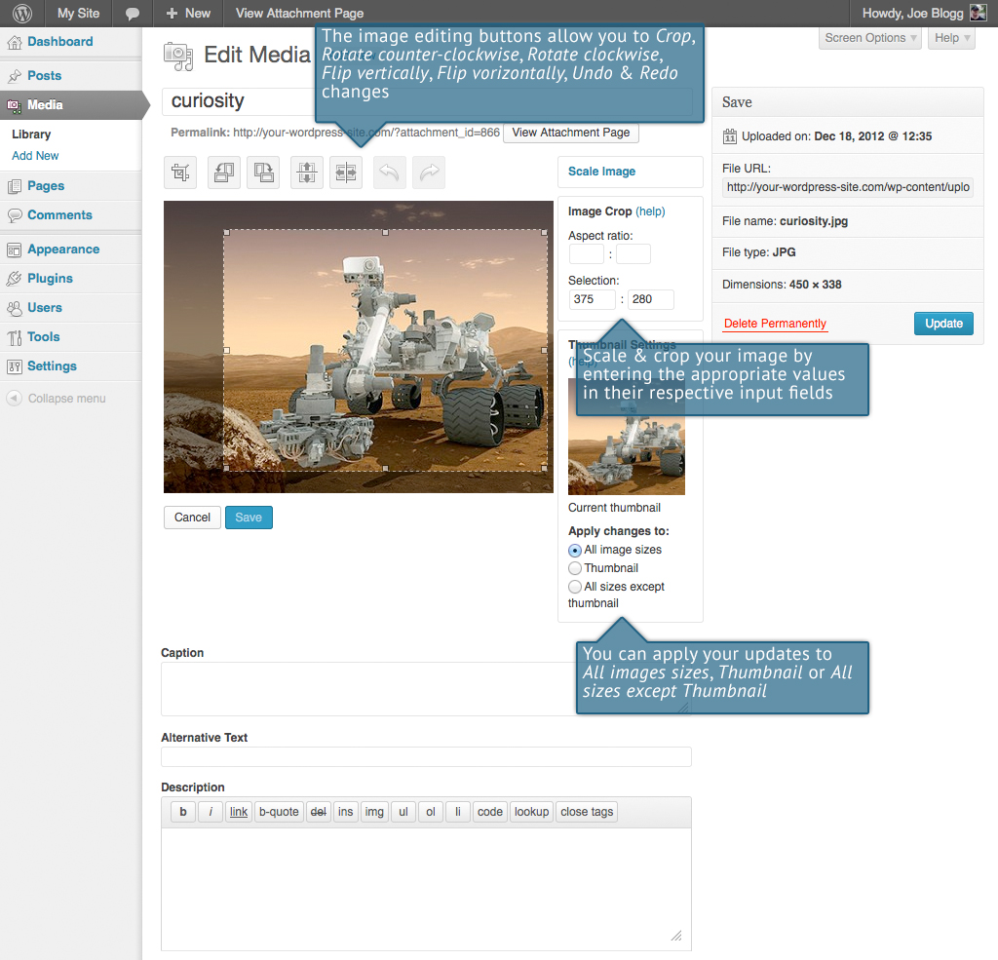

Click the Scale Image link to resize the image proportionally. For best results, scaling should be done before performing any other operations like cropping, rotating, etc..

To scale your image to a new size, simply enter the width or height dimensions in the appropriate field (w x h) and click the Scale button. After entering one value, the other value will change automatically so as to keep the image in proportion. The original image dimensions are displayed just above the input fields, for your reference.

There are several ways to crop your image. The easiest is to simply click on the image and drag the selection box to the appropriate size. If you’d like your image cropped to a specific ratio, enter the values in the Aspect Ratio input fields (e.g. 1:1 (square), 4:3, 16:9 etc.). You can then hold down the shift key and drag one of the edges of your selection to enlarge or reduce the size, while keeping this aspect ratio locked. If there is already a selection made, specifying the aspect ratio will automatically change the selection to match it.

Whenever the selection box is adjusted, the dimensions are displayed in the Selection input fields. You can also manually enter the dimensions of the selection box (in pixels) by entering values into these two fields. Once your selection box is adjusted, simply click the Crop button just above the image to crop the image to this new size.

By selecting one of the options in the Thumbnail Settings panel, you have the option to apply your changes to All image sizes, just the Thumbnail image or All sizes except Thumbnail.

Click the Save button to save your changes.

Click the Update Media button to return to the main Media Library page.

If you’d like to revert back to your original image, click the Edit Image button again to return to the image editor. A new Restore Original Image link is displayed just below the Scale Image link. Click the Restore Original Image link and then click the Restore image button to discard your changes and restore your original image.

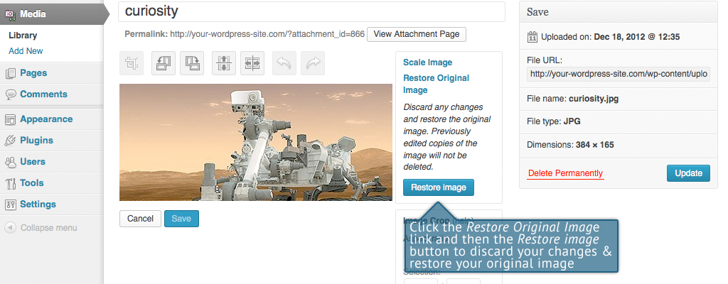

## Deleting a File from the Media Library

To delete a file from the Media Library, click on the Delete Permanently link that appears beneath the file name when hovering your cursor over each row. You will be prompted with the following message; “You are about to permanently delete the selected items. 'Cancel' to stop, 'OK' to delete.”

Click the OK button to delete the file or click the Cancel button to return to the Media Library.Links

In WordPress 3.5 the Link Manager is disabled by default, to help simplify the Dashboard interface. When you update to WordPress 3.5, if you are currently using the Links Manager, then it will remain enabled for you. If you’re not currently using it or if you’re installing WordPress for the first time and would like to use it, you can download the [Link Manager plugin](http://wordpress.org/extend/plugins/link-manager/) from the WordPress Plugin Directory. Once activated, this will enable the Links option in your Dashboard menu.

(The screenshots in this section show the Links menu enabled in your dashboard.)

Links can be added here, for displaying on your site. They’re usually displayed using Widgets. Links may be separated into Categories; these are different from the Categories used on your Posts. How links display on your website will be dependent on the WordPress theme in use.

When you click on the Links menu option you’ll be shown a list of the existing website links.

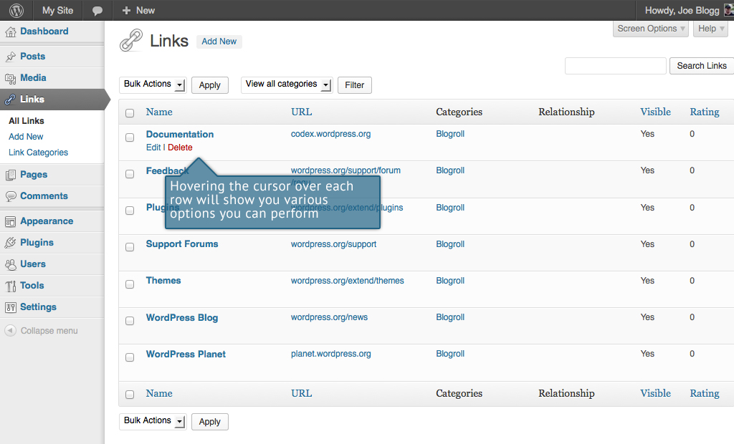

Along with the Link name, by default, you’ll also see the URL, Link Category, Relationship, Visibility and Rating.

* Name – The name of the Link
* URL – The destination URL (Web Address) of the Link
* Categories– All Links must belong to at least one Category. The Categories that are assigned to each link are shown here
* Relationship – This column displays all of the [XFN](http://gmpg.org/xfn/) relationships for this Link.
* Visible – Whether or not the Link is visible on your site
* Rating – The rating, from 0 to 9, for this link, where 0 implies that the link is unrated. What the rating system actually defines on your site is up to you to decide

When hovering your cursor over each row, two links will appear beneath the link name.

* Edit – Allows you to edit the Link properties such as Name, Web Address, Description etc.
* Delete – Deletes the Link permanently from the list of links

## Adding a New Link

To add a new Link, click on Add New link in the left hand navigation menu or the Add New button at the top of the page.

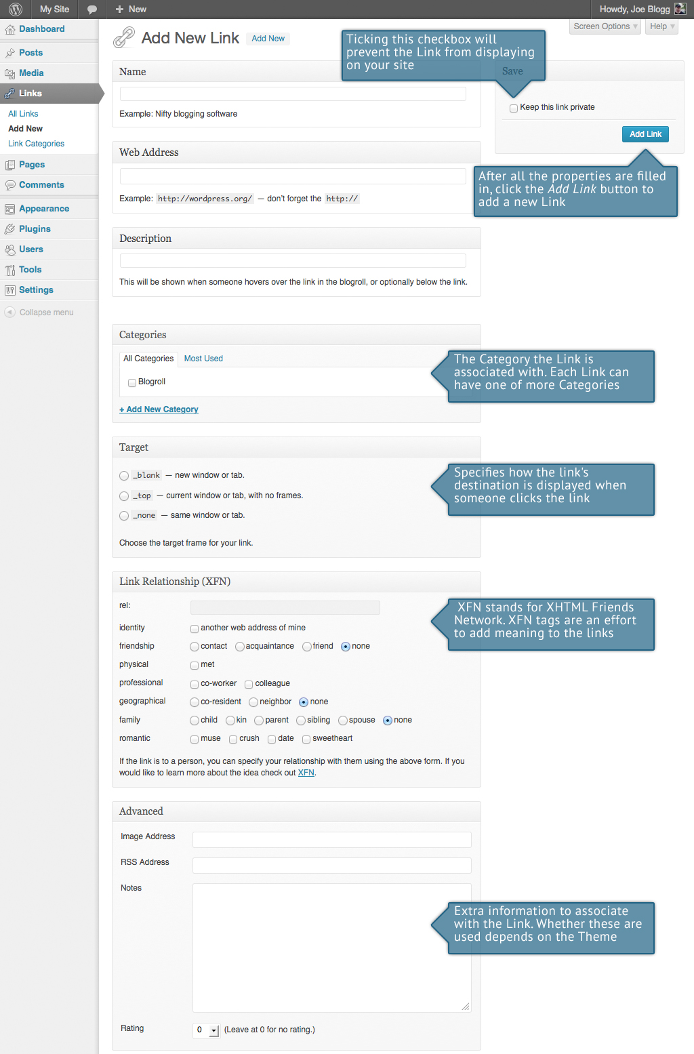

Fill in the blank fields and then click the Add Link button to add a new Link. Only the link’s web address and name (the text you want to display on your site as the link) are required fields.

* Name – The name of the link is what is actually displayed on your site
* Web Address – This is where the link points. Also called a URL, this is the destination, or the site you want to go to when you click the link.
* Description – This is the description for your link. How the description is displayed on your site depends on which theme you use
* Categories – Each Link can have one of more Categories associated with it. If you wish to add a new Category, simply click the + Add New Category link, type the new category name into the blank field that appears and then click the Add button. If no Categories are selected prior to saving, the Default Link Category will be assigned. The Default Link Category can be changed within your WordPress Settings.
* Target – Specifies how the link's destination is displayed when someone clicks the link. Will default to _none if no option is selected prior to saving
* Link Relationship (XFN) – [XFN](http://gmpg.org/xfn/) stands for XHTML Friends Network. WordPress allows for the generation of XFN attributes automatically so you can show how you are related to the authors/owners of site to which you are linking. XFN tags are an effort to add meaning to the links. More information on Link Relationship can be found on the [WordPress Codex](http://codex.wordpress.org/Links_Add_New_SubPanel#Link_Relationship_.28XFN.29)
* Advanced – Allows for more advanced manipulation of your links. How these options affect your site will be dependent on the WordPress theme in use

To keep this link Private, click the Keep this link private checkbox, just above the Add Link button. This will make the link invisible when the Links are displayed on your site.

## Edit an Existing Link

To edit an existing link, click the Link name or the Edit link that appears underneath the name when hovering your cursor over the row on the screen that lists all your links. The screen that appears will be the same as when adding a new Link, except that all the fields will be populated with the values of the Link that you’re editing. After making your changes, click the Update Link button to save your changes.

## Delete an Existing Link

To delete an existing link, click the Delete link that appears underneath the name when hovering your cursor over the row on the screen that lists all your links. You will be presented with the following message, “You are about to delete this link. 'Cancel' to stop, 'OK' to delete.”

Click the OK button to delete the Link permanently or click the Cancel button to return to the list of Links.

If you would like to permanently delete numerous Links at once, click the checkboxes next to the Links you would like to delete and then choose Delete from the Bulk Actions dropdown list at the top of the page. After selecting Delete, click the Apply button to immediately delete the selected Links (you will not be prompted to confirm your choice).

## Updating Link Categories

You can use Link Categories to group related links. The default Link Category is ‘Blogroll’ but this can be easily changed in the Settings > Writing section. A ‘blogroll’ is simply a list of links to various blogs or news sites. If you prefer, this Category name can be easily changed to ‘Links’ or something similar simply by editing the Link Category and updating the Name and Slug.

There are two ways to add Link Categories. They can be added whilst adding or editing a Link or they can be added via the Link Categories menu option. Adding Categories whilst editing your Link, will automatically assign those Link Categories to your Link. Adding Link Categories using the Link Categories menu option will simply add them to the list of available Link Categories.

When you click on the Link Categories menu option you’ll be shown a list of Link Categories that have already been added along with some blank fields that allow you to add a new Link Category.

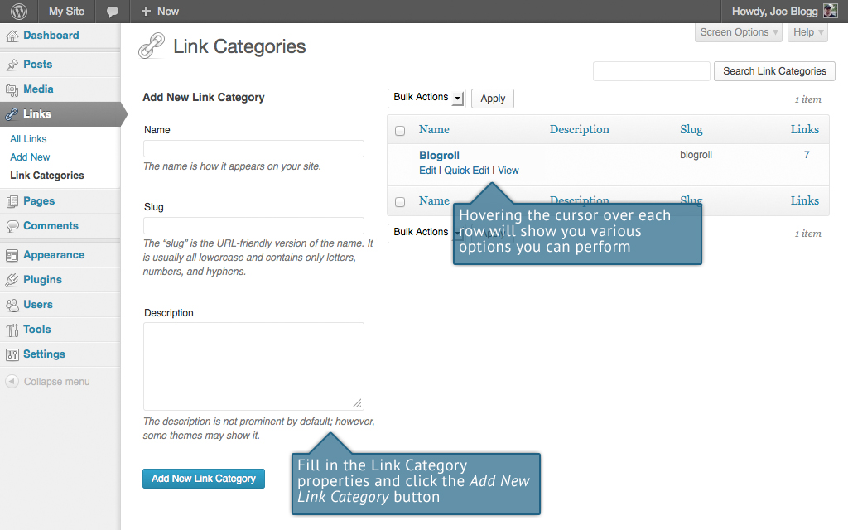

To add a new Link Category, fill in the blank fields and then click the Add New Link Category button:

* Name – The name of the Link Category
* Slug – The Slug is the URL-friendly version of the name. It is usually all lowercase and contains only letters, numbers, and hyphens
* Description – The description is not prominent by default; however, some themes may display it

Once you add a new Link Category it will appear in the list of Link Categories on the right side of the screen.

When hovering your cursor over each row in the list of Link Categories, a few links will appear beneath the Category name.

* Edit – Allows you to edit the Category properties such as Name, Slug and Description
* Quick Edit – Allows you to quickly edit the Link Category Name and the Link Category Slug
* Delete – Deletes the Link Category permanently from the list of Link Categories. After clicking Delete you will be prompted to confirm your choice. Click OK to delete the Link Category or Cancel if you don’t want to delete it. The Delete link won’t display for the default Link Category
* View – Displays your Link Categories, if possible

If you would like to permanently delete numerous Link Categories at once, click the checkboxes next to the Link Categories you would like to delete and then choose Delete from the Bulk Actions dropdown list at the top of the page. After selecting Delete, click the Apply button to immediately delete the selected Link Categories (you will not be prompted to confirm your choice).

Deleting a Link Category does not delete the Links in that Category. Instead, links that were only assigned to the deleted Link Category are set to the default Link Category. The default Link Category is set to Blogroll but this can be changed within the Settings > Writing section.

Comments

Comments are a feature of blogs which allow readers to respond to Posts. Typically, readers simply provide their own thoughts regarding the content of the post, but they may also provide links to other resources, generate discussion, or simply compliment the author for a well-written post. Comments allow you to interact more with your site visitors as well as generate feedback and discussion on your Posts.

Comments can be controlled and regulated through the use of filters for language and content, and if you prefer, can also be queued for approval before they are visible on the web site. This is useful in dealing with [comment spam](http://codex.wordpress.org/Comment_Spam).

When you click on the Comments menu option, you’ll be shown a list of all the comments on your site.

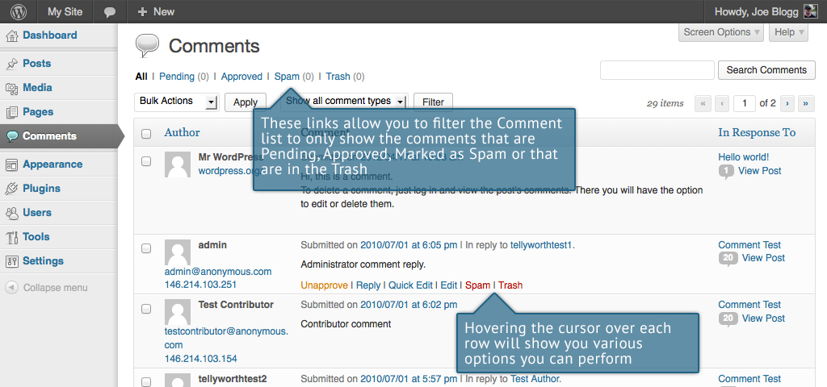

At the top of the screen there are links that allow you filter the comment list to only show the comments that are Pending, Approved, Marked as Spam or that are in the Trash. The number in brackets will advise how many there are for that particular type.

As well as the standard settings that allow you to manage your comments, the default WordPress install comes with an excellent Plugin that helps to filter out Spam from your comments. This Plugin is called Akismet.

After activating the Akismet plugin, you need to supply it with an API Key. You can grab an API key and find out more information on the [Akismet website](http://akismet.com).

When hovering your cursor over each row in the list of Comments, a few links will appear beneath the comment.

* Unapprove/Approve – Allows you to unapprove the comment. This will stop it displaying on your site. If the comment is already unapproved then this link will change to Approve, to allow you to approve the comment.
* Reply – Allows you to write a reply comment
* Quick Edit – Allows you to quickly edit the commenter’s Name, Email or URL as well as the actual comment
* Edit – Allows you to edit the commenter’s Name, Email or URL as well as the actual comment. It also allows you to mark the comment as either Approved, Pending or Spam and change the Date and Time
* Spam – Allows you to mark the comment as Spam
* Trash – Allows you to mark the comment as Trash. Once it’s in the Trash, you can either restore it if you made a mistake, or delete it permanently

If you would like to change the status of numerous Comments at once, click the checkboxes next to the Comment(s) you would like to change and then choose either Unapprove, Approve, Mark as Spam or Move to Trash from the Bulk Actions dropdown list at the top of the page. After selecting the appropriate option, click the Apply button.

## Replying to a Comment

To respond to a comment that someone has written on one of your Posts, simply hover the mouse over the comment and click the Reply link when it appears. An edit field will then appear beneath the comment where you can type your reply.

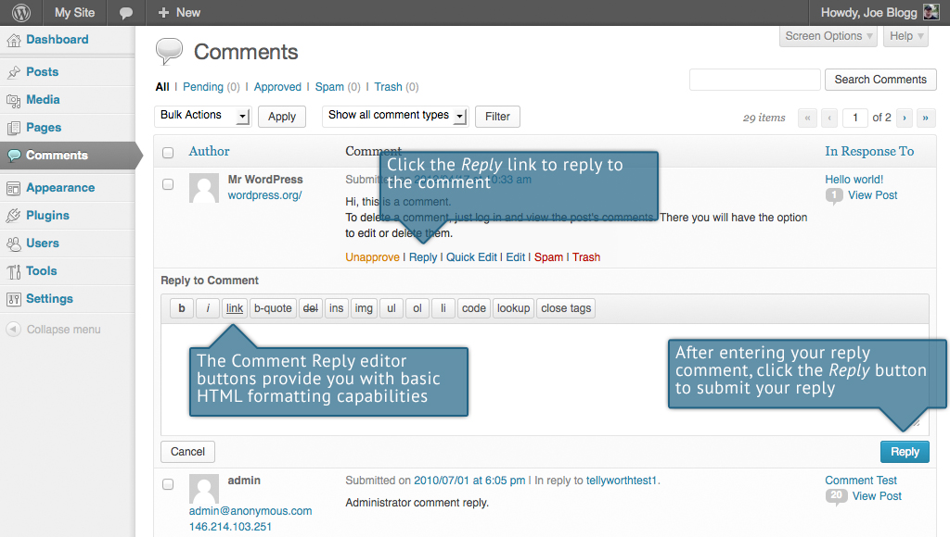

When you’ve written your comment, click the Reply button or alternatively, click Cancel to stop replying and cancel your editing.

The editor that appears when replying or editing a comment (using either the Reply, Quick Edit or Edit links) is much like the editor when creating or editing a Page or Post, only not as intuitive. At the top of the editor there are numerous formatting buttons. These buttons provide you with basic html formatting capabilities when composing a new reply comment or editing an existing comment.

The buttons work in two ways. Clicking a button without highlighting any text first, will simply insert the opening html tag relevant for that button. As an example, clicking the Bold button will insert the <strong> html tag into your comment. Clicking the Bold button again will close the tag by inserting the closing </strong> tag. If you highlight some text prior to clicking a button, both the opening and closing tags will be inserted around that highlighted text. For example, highlighting the text, ‘bold text’, prior to clicking the Bold button will insert ‘<strong>bold text</strong>’.

|  |  |
| --- | --- |
|  | Bold – Bold text |
|  | Italic – Italicise text |
|  | Link – Used to insert a website link. When the button is clicked a popup window will appear where you type in the URL that you would like to link to |
|  | Blockquote – Used as a way of showing a quote. How this looks will be entirely dependent on the Theme that your site is currently using |
|  | Delete - Used as a way of showing deleted text. How this looks will be dependent on the Theme but is usually done by showing the text with a strikethrough |
|  | Insert - Used as a way of showing inserted text. How this looks will be dependent on the Theme but is usually done by showing the text with an underline |
|  | Image – Used to insert an image into the comment. When the button is clicked a popup window will appear where you type in the URL of the image that you would like inserted |
|  | Unordered List – Used to insert an unordered (or un-numbered) list |
|  | Ordered List – Used to insert an ordered (or numbered) list |
|  | List Item – Used to insert a list item into your ordered or un-ordered list |
|  | Code – Used for indicating a piece of code |
|  | Lookup – Will lookup the highlighted (or entered word, if nothing is highlighted) on Answers.com |
|  | Close Tags – Used to close open tags. If for example, you clicked both the Bold and Italic buttons to insert their opening tags, clicking the close tags button will insert both of the matching closing tags, in the correct order |

## Editing a Comment

There are two ways to edit a comment. Once you hover over an individual comment you can click the Quick Edit link or the Edit link. Both perform a similar function except that the Edit option also allows you to mark the comment as either Approved, Pending or Spam and change the Date and Time.

### Quick edit

Clicking Quick Edit will replace the comment with an editor that allows you to update the comment, the comment authors name, email address and URL.

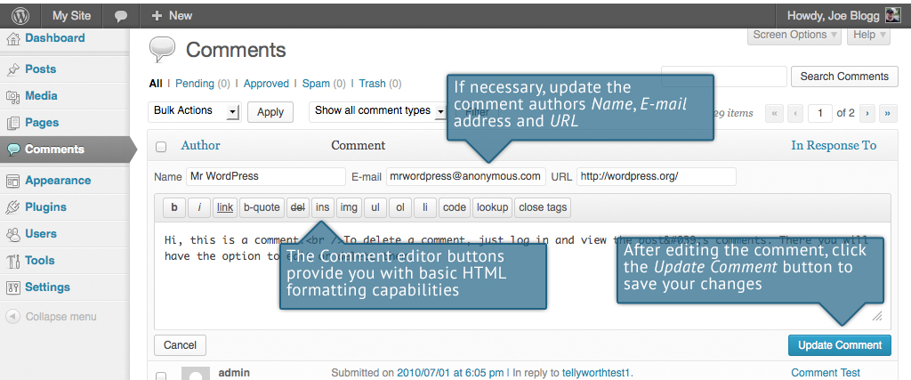

Once you have finished, click Update Comment to save your changes or click Cancel to cancel your changes and return to the list of comments.

### Edit

Clicking Edit will display the editor on a new page. Like the Quick Edit option, you can update the comment, the comment authors name, email address and URL. The Edit option also gives you the ability to set the comment Status and change the comment Date and time. The comment status can be set to Approved, Pending or Spam. You also have the option to move the item to the Trash by clicking on the Move to Trash link.

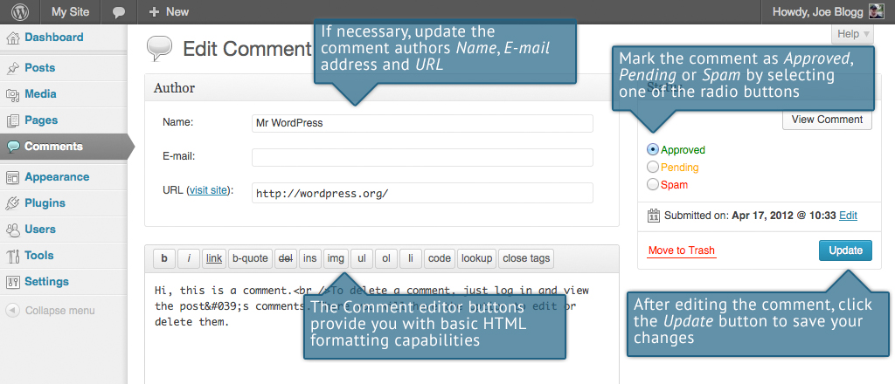

You can change the date and time that the comment was submitted by clicking on the Edit link next to the date and time. After clicking Edit, several fields appear below the original date and time. Update the fields if required and click the OK button to save the new date and time.

Once you have finished updating the comment, click the Update button to save your changes. If you want to cancel your changes, click the browser Back button or click on the Comments menu option to return to the list of comments.

## Unapproving and Approving Comments

If an inappropriate comment has been submitted, you may wish to Unapprove it. This will stop the comment from displaying on your site. Unapproved comments will displayed with a yellow background within your list of comments. Hovering your cursor over the comment will display an Approve link instead of an Unapprove link.

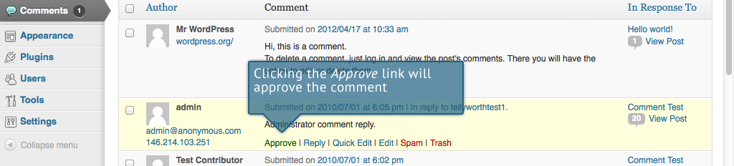

## Marking Comments as Spam and Trash

If a Spam comment has been posted to your site you can mark it as Spam simply by hovering your cursor over the comment and clicking the Spam link.

If you simply want to remove a comment, hover your cursor over it and click the Trash link.

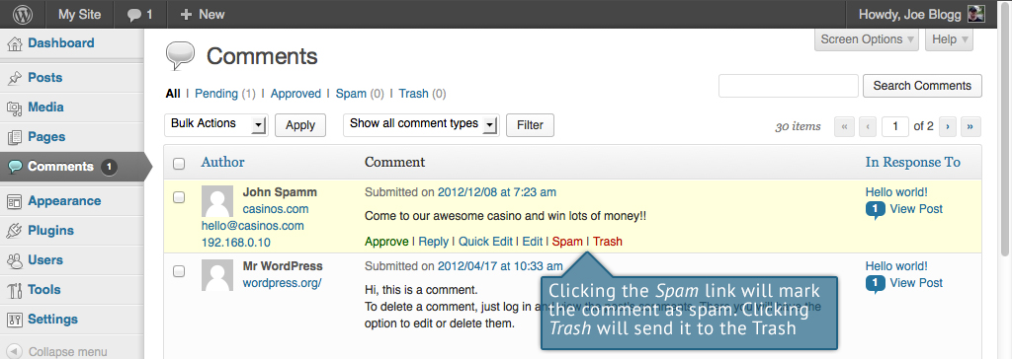

To empty the Trash, click on the Trash link at the top of the page to display all the comments that have been marked as Trash. This link will be displayed along with a number within brackets which indicates how many comments are marked as Trash. To permanently remove all these comments, click the Empty Trash button. You will not be prompted for confirmation.

To remove all the Spam comments, click on the Spam link at the top of the page to display all the comments that have been marked as Spam. This link will be displayed along with a number in brackets which indicates how many Spam comments there are. To permanently remove all these comments, click the Empty Spam button. You will not be prompted for confirmation.

You can also delete a single spam comment permanently by clicking on the Delete Permanently link that appears when hovering your cursor over each row. You will not be prompted for confirmation.

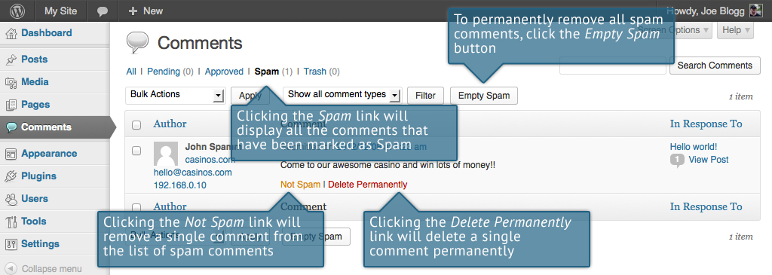

If you find there are comments that have been marked as Spam that shouldn’t be, click the checkboxes next to them and select Not Spam from the Bulk Actions drop down at the top of the page. Click the Apply button to confirm your choice. Alternatively, click the Not Spam link that appears when hovering your cursor over each row.

Appearance

The various Appearance SubPanels allow you to change numerous options in regards to how your site looks and behaves. If your site has been setup for you by a third party then it’s more than likely that you won’t need to change any of the settings in here.

Depending on the theme that your site is running, you may find that you don’t have all the menu options listed here, or you may have a couple of different ones. The reason for this is that a couple of the options under the Appearance section are theme based. That is, for the default Twenty Twelve theme, they allow you to set various options for how your theme displays. Not all themes will have these option pages, or if they do, they may be under another menu entirely.

## Selecting your Theme

The overall appearance of a WordPress site is controlled by the Theme. Although there is a default theme that comes installed with WordPress, most people will either download a new theme, purchase one, or have one custom designed and built. There are hundreds of places where themes can be downloaded for free and/or for a small fee. One of the best places to start looking for themes is in the [Theme Directory](http://wordpress.org/extend/themes/) on the WordPress site itself.

Clicking on the Appearance menu option will default you at the Themes screen. The theme that is currently active is shown at the top of the screen. Underneath this are all the other themes that are installed, but not currently in use. To see a preview of your site in another theme (that isn’t currently active), you can click the Live Preview link associated with each theme. While the preview screen is displayed, you’re able to click your site links to view your various pages in the new theme layout as well as make various theme changes. To change your site to another Theme, click the Activate link underneath the Theme you would like to switch to. Alternatively, if the preview window is displaying, you can click the Save & Activate link in the top left corner of the window to activate the theme.

Clicking on the Install Themes tab at the top of the page allows you to search the WordPress Theme Directory for new themes as well as install them directly from within your Dashboard.

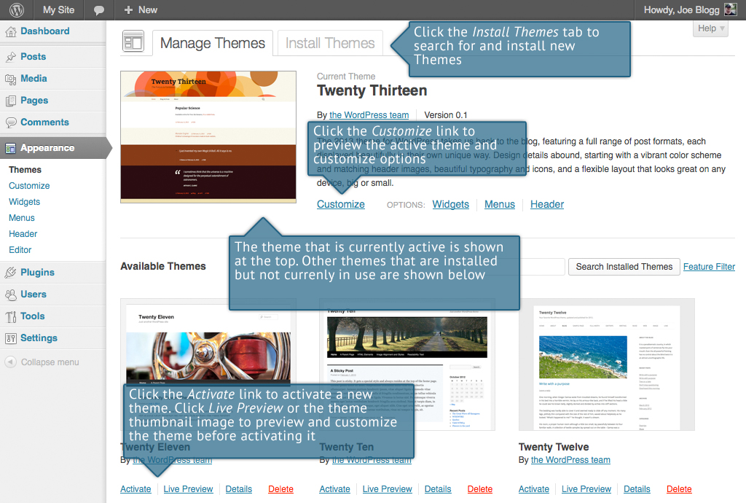

### Previewing and Customizing your Theme

As well as the ability to preview a theme, you can now also update various theme settings all while previewing the changes live. The options that you can change will be dependent on the individual theme.

For the currently active theme, clicking the Customize link or the theme thumbnail image allows you to update various settings whilst also previewing those changes. Until you click the Save & Publish button, only the theme preview window is updated, not the theme on your live site.

For all other installed themes that are not currently active, click the Live Preview link or the theme thumbnail image to preview the theme, update its settings and activate the theme. Until you click the Save & Activate button, only the theme preview window is updated, not the theme on your live site.

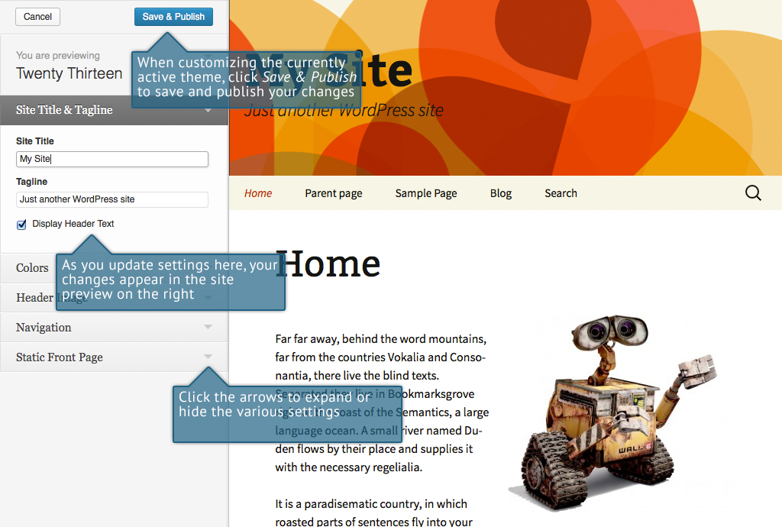

## Widgets

Widgets are independent sections of content that can be placed into any widgetized area provided by your theme. Although these widgetized areas are commonly called ‘Sidebars’ and are quite often located in the left or right hand column, they can be also located anywhere within your site and are entirely dependent on the current theme as to their location. There are numerous widgets available by default which allow you to add extra content to your site, such as Recent Post Comments, Category Lists or Custom Menus, just to name a few. New Widgets can also be installed via Plugins and again, depending what the plugin is used for will enable you to add extra functionality to your site.

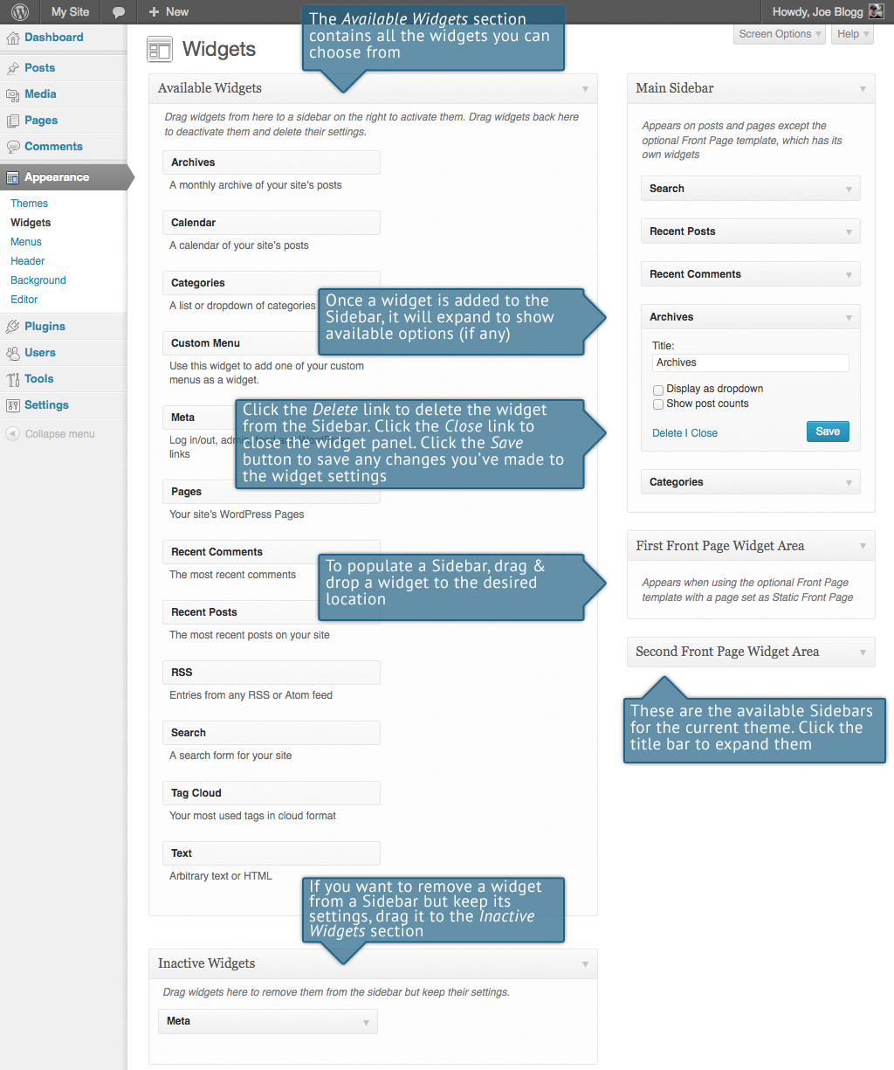

The Available Widgets section contains all the widgets you may choose from. To populate one of your Sidebars, drag and drop a widget to the desired location. Once the Widget is dragged to the Sidebar, it will open up to allow you to configure its settings. Click the Save button within the Widget to save your settings.

If you want to remove a widget from a Sidebar but save its settings for future use, just drag it into the Inactive Widgets section. If you simply want to delete the Widget from your Sidebar, click the Delete link within the Widget.

## Updating the Menu

If your theme supports custom menus, you can make modifications to them from the Menus option. Menus can contain links to Pages, Posts, Categories, Custom Links or other content types.

In WordPress 3.6, the Menus option has been made a little more intuitive and user friendly by separating the options onto different tabs.

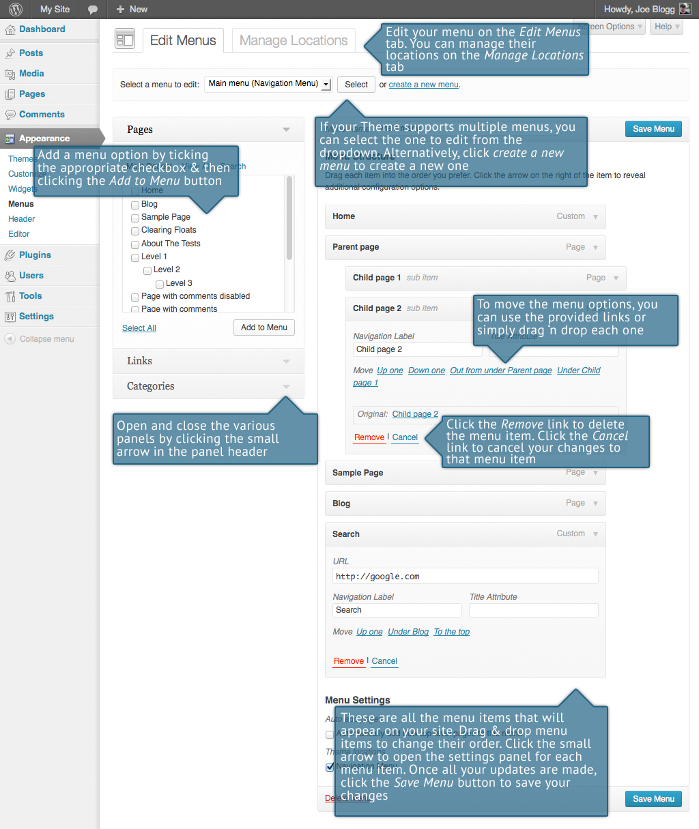

### Adding a New Menu

Depending on the current Theme being used, your site may make use of more than one navigation menu. Sometimes you might have multiple menus in your site header, other times you may even have menus located in the sidebar or footer of your site.

To add a new menu, hover your cursor over the Appearance menu option in the left hand navigation menu and in the fly-out menu, click the Menus link. Alternatively, click the Appearance menu option and then click the Menus link underneath.

On the screen that’s displayed, click the create a new menu link. You’ll be presented with a screen similar to below. Enter a name for your new menu in the Menu Name input field. Click the Create Menu button to create your new menu.

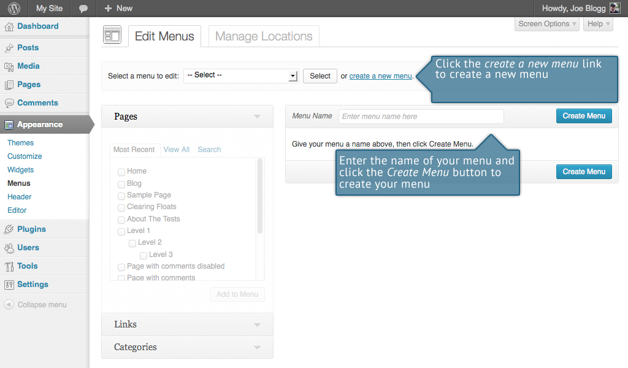

### Editing an Existing Menu Item

Your current list of menu items resides in the right hand column on the menu screen. If there are multiple menus on your site, there will be a dropdown list displayed at the top of the page that enables you to select the menu that you would like to edit. Simply select the menu you would like to edit from the Select a menu to edit dropdown list and then click the Select button. The menu items for your selected menu will then be displayed.

The items in this right-hand column on the Menus page will match the menu items that appear on your website. Clicking on the down arrow next to each menu item name will show an options panel for that particular menu item. In this options panel, there are several items that can be updated/changed. You can show or hide extra fields such as Link Target, CSS Classes, Link Relationship (XFN) or Description using the Screen Options tab at the very top-right of the screen.

* URL – Used within Custom Links and will contain the URL to navigate to when that menu item is clicked
* Navigation Label – This is the label that will display within the actual menu on your website
* Title Attribute – This is the tooltip that appears when the mouse cursor hovers over the menu item
* Link Target – (Hidden by default) You can set the menu item to open in the Same window or tab (which is the default) or in a New window or tab
* CSS Classes – (Hidden by default) Optional CSS Classes to add to this menu item
* Link Relationship (XFN) – (Hidden by default) Allows for the generation of XFN attributes so you can show how you are related to the authors/owners of site to which you are linking
* Description – (Hidden by default) The description for the link. This may or may not appear, depending on the theme

Each menu item can be moved to a new location in the menu hierarchy by using either the links underneath the Navigation Label input field or by clicking on the title area of the menu item and dragging ‘n dropping the menu to new location. If you choose to drag ‘n drop your menu items, the cursor will turn into a four-pointed arrow when you’re hovering over the correct area.

After making updates to your menu items, click the Save Menu button at the top or bottom of the screen.

### Adding a New Menu Item

By default, only the Pages, Links and Categories panels are shown. If you’d like to add Posts, Tags or Post Formats as menu items, you simply use the Screen Options tab at the top-right of the screen to enable these panels as well.

To add a new Page as a menu item, tick the checkboxes in the Pages panel, next to each of the Pages that you’d like to add. You can select one Page at a time or multiple. After selecting your Pages, click the Add to Menu button. The new menu items will append to the bottom of the current list of menu items. The menu item name will default to the Page name. To change this, simply click on the down arrow next to the menu item name to view the options panel and then update the Navigation Label to your preferred name. After making your updates, click the Save Menu button at the top or bottom of the screen. The steps to add a Post, Post Format, Category or Tag as a menu item are exactly the same as adding a Page.

To change the order that the menu options appear in, simply place your cursor over the title area of the menu item you’d like to move. When the cursor changes to a four-pointed arrow, click and drag the menu item to its new location. Depending on how your menu is configured within your theme, it’s even possible to create the multi-level hierarchy required for dropdown menus. After moving your menu items around, don’t forget to click the Save Menu button at the top or bottom of the screen to save your changes.

### Adding a Custom Link Menu Item

Use the Custom Links panel to add a custom link to your menu, such as a link to an external website. Simply type in the website URL in the URL field and the menu name in the Link Text field. Click the Add to Menu button when done. Use the same steps outlined above to adjust the order of the menu item and click the Save Menu button at the top or bottom of the screen to save your changes.

### Deleting a Menu Item

To delete a menu item click on the down arrow next to the menu item name to view the options panel for that item and then click the Remove link. After making your updates, click the Save Menu button at the top or bottom of the screen.

### Managing Menu Locations

After you create a menu, you also need to tell WordPress where to use it. This is where the Manage Locations tab on the Menus page comes in.

After clicking the Manage Locations tab on the Menus page, you will be shown a page similar to below, with a list of the various menu locations used in your Theme. You may have one menu location or you may have multiple, depending on the Theme currently in use. Your menu wont necessarily be called ‘Navigation Menu’ either, as shown below. Again, that will depend entirely on your Theme.

Assign an existing menu to the appropriate location by selecting it from the dropdown list. Click the Save Changes button to save your changes.

Alternatively, you can choose to create a new menu and automatically assign it to the location by clicking the Use new menu link.

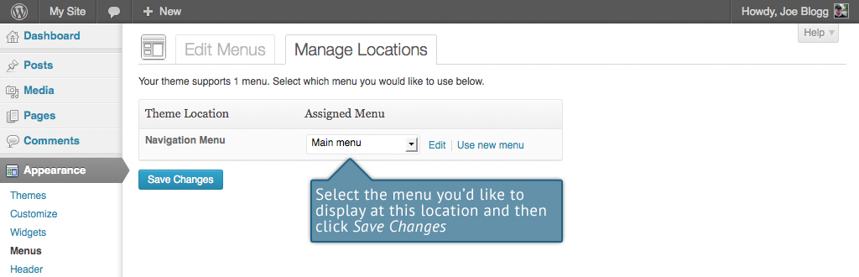

## Header

The Header menu option will only be available if your current Theme is making use of this option. It allows you to choose an image to display in the header area. You can choose one of the images that comes with the theme or you can upload your own image. You can also choose to display a static image or a random image. The Site Title and Tagline in the header area can be turned on or off using the Show header text with your image option on this page. Again, depending on the theme you’re using you may or may not have this, or a similar option.

## Background

The Background menu option is another theme specific menu. It allows you to choose a background image and the background colour for the theme. Again, depending on the theme you’re currently using you may or may not have this, or a similar option.

## Editor

The Editor menu allows you to edit the individual [CSS](http://en.wikipedia.org/wiki/Css) and [PHP](http://en.wikipedia.org/wiki/Php) files which make up your Theme. Normally once a theme is installed and configured on your site, there's no need to make any changes within here. Extreme care should be taken with this option to avoid making changes to files that will affect how your site is displayed. Incorrectly modifying any files within this section can cause your site to display incorrectly or at worst, not at all. Extra caution must be taken if you intend to make any changes here.

|  |  |
| --- | --- |
|  | It cannot be stressed enough how dangerous this option is if you know nothing about HTML, CSS or PHP. Modifying your theme files can drastically change how your site displays and depending on what gets changed, can even stop your site from displaying altogether. |

Plugins

Plugins extend and expand the functionality of WordPress. Once a Plugin is installed, you may activate it or deactivate it here. There are thousands of plugins available that provide a huge range of functionality. The easiest place to find them is within the [Plugin Directory](http://wordpress.org/extend/plugins/) on the WordPress site. You can search the WordPress Plugin Directory and install new plugins by clicking on the Add New button at the top of the page or the Add New link in the left hand navigation menu. If one of your installed Plugins has updates available, a small number will appear next to the Plugins menu option. The number will advise you as to how many Plugins have updates available. Prior to updating a Plugin, it’s wise to verify that the Plugin functionality hasn't changed significantly as to adversely affect your site. It’s also recommended to check that the Plugin still works as expected, once it has been upgraded.

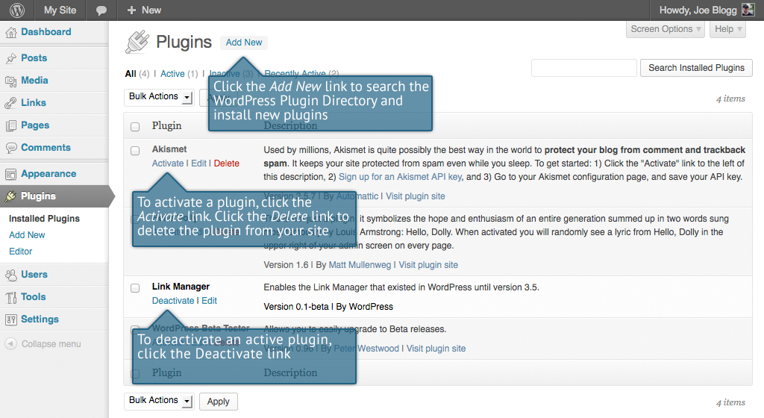

Users

This screen lists all the existing users for your site. Users with roles other than Administrator will see fewer options when they are logged in. Depending on your Role, you can also add new users as well as manage their Roles.

At the top of the screen there are links that allow you filter the list of Users based on the User Roles. The number in brackets will advise how many there are for that particular type.

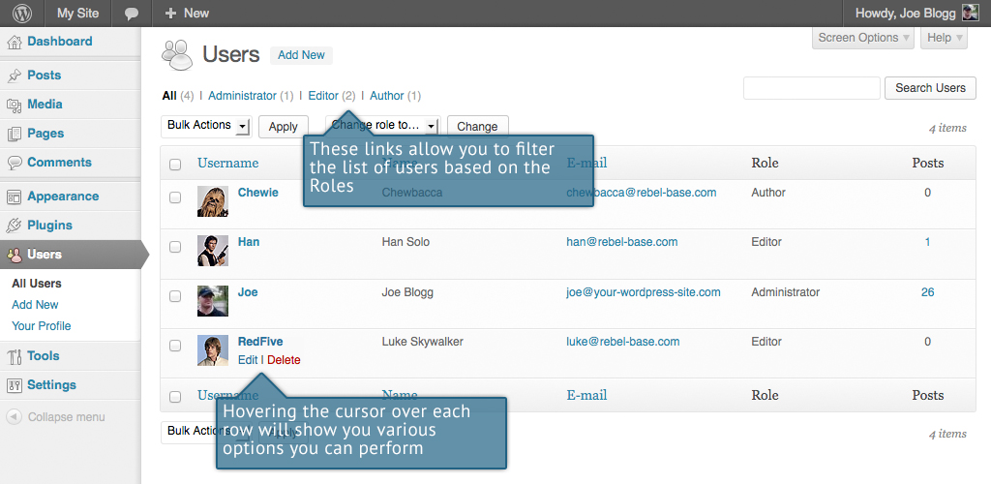

When hovering your cursor over each row in the list of Users, links will appear beneath the user name.

* Edit – Allows you to edit the user profile
* Delete – Allows the User to be deleted. This link won’t be available for your own profile

A User can have one of five defined roles as set by the site admin: Site Administrator, Editor, Author, Contributor, or Subscriber.

* Super Admin – (Only relevant when running multiple sites from one WordPress installation). Someone with access to the blog network administration features controlling the entire network.
* Administrator – Somebody who has access to all the administration features
* Editor – Somebody who can publish and manage posts and pages as well as manage other users' posts, etc.
* Author – Somebody who can publish and manage their own posts
* Contributor – Somebody who can write and manage their posts but not publish them
* Subscriber – Somebody who can only manage their profile

When WordPress is first installed, an Administrator account with all capabilities is automatically created.

The [avatar](http://en.wikipedia.org/wiki/Avatar_%28computing%29) that is displayed in the list of Users is using what's called a Gravatar. A Gravatar is a Globally Recognized Avatar. Gravatars are currently used by a huge number of blogs, forums, chat sites and the like. Rather than having to upload an avatar on each and every system you sign up to, Gravatars allow you to have one avatar that is viewable everywhere. To create a Gravatar, simply go to [gravatar.com](http://gravatar.com) and sign up. To use your Gravatar within WordPress, simply add an email address to your Profile that you’ve configured within the Gravatar site and it will automatically display.

## Adding a New User

To add a new user, click on the Add New link in the left hand navigation menu or the Add New button at the top of the page.

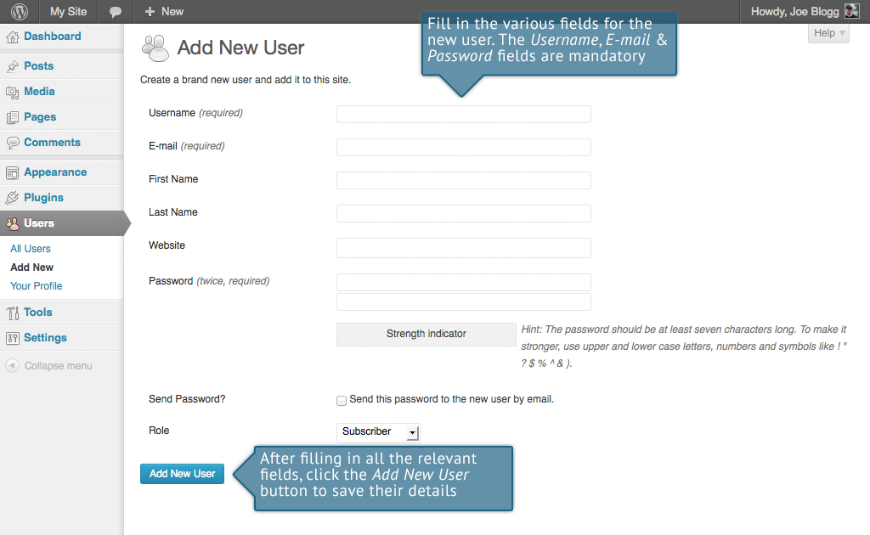

Once the above page is displayed, simply fill in the various fields and click the Add New User button.

* Username – (mandatory) Enter the username of the new user here. This will also be used as the Login name for the user. Once saved, the Username can’t be changed
* E-mail – (mandatory) Enter a valid email address of the new user here. The email address must be unique for each user. If a published Post or Page is authored by this user and approved comments are made to that post or page, a notification email is sent to this email address
* First Name - Enter the first name of the new user here
* Last Name – Enter the last name of the new user in this text box
* Website – You may enter the new user's website URL in this text box
* Password – (mandatory, twice) Enter a password for the new user twice here, once in each text box.
* Strength indicator – This indicates if the password you entered is Very Weak, Weak, Medium, or Strong (displayed in green). The stronger the password the more secure the login. Hint: The password should be at least seven characters long. To make it stronger, use upper and lower case letters, numbers and symbols like ! " ? $ % ^ & )
* Send Password? – Check the box to send this password to the new user by email
* Role – Select the desired Role for this user from the dropdown list

## Deleting a User

To delete a user, click on the Delete link that appears beneath the user name when hovering your cursor over each row. The Delete link wont appear for the user that is currently logged in.

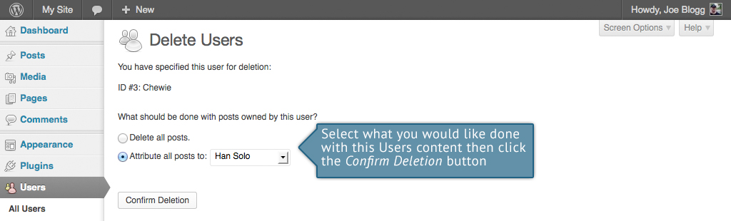

Along with deleting the user you will be given the choice of what to do with all the content currently assigned to that User. The available choices are:

* Delete all posts – This will delete all the content which this user created.
* Attribute all posts and links to – This will assign all the content currently linked to this User, to another User of your choosing. Simply select the User from the dropdown list

After making your selection, click the Confirm Deletion button to remove the User.

## Editing your Profile

To edit your profile details, simply click on your user name, when viewing the list of Users or click on the Edit link that appears beneath your user name when hovering your cursor over each row. Alternatively, click on the Your Profile link in the left hand navigation.

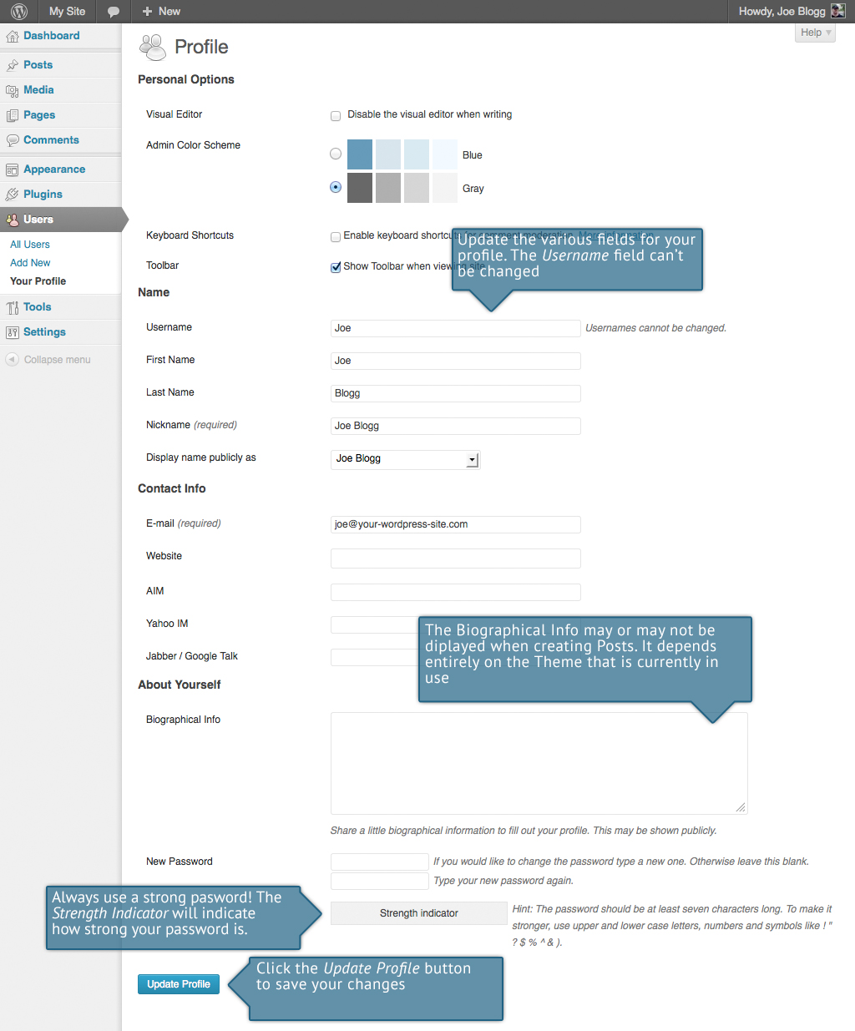

If you’re an Administrator and would like to edit someone else’s profile, click on their user name when viewing the list of Users or click on the Edit link that appears beneath their user name when hovering your cursor over each row.

Update the appropriate fields and then click the Update Profile button to save all your changes.

Personal Options

* Visual Editor – Checking this box disables the visual editor when writing and uses the plain html editor
* Admin Color Scheme – Check this radio button next to the colour scheme desired for the administrative panels. You have the choice of Blue or Gray
* Keyboard Shortcuts – Checking this box Enables keyboard shortcuts for comment moderation. Keyboard shortcuts are designed to allow you to rapidly navigate and perform actions on comments
* Admin Bar – Checking this box will display the Admin Bar at the very top of your website (only for the person who is currently logged in)

Name

* Username – You cannot edit your Username because it is used as your Username during the login process. Even an Administrator cannot change your Username. Usually, no one else ever needs to see your Username
* First name – Enter your first name in this text box
* Last name – Enter your last name in this text box
* Nickname – (mandatory) The nickname is a requirement for every user. It may be the same as your Username or it can be different. If you don’t supply a Nickname, then the Username will be placed in this field
* Display name publicly as – Select how your name is cited on your blog, from the dropdown list. You can choose from several choices: Nickname, Username, First Name, Last Name, ‘First Last’, or ‘Last First’. If you prefer ‘Last First’, insert a comma after your last name in the Last Name text field and choose the last option from the dropdown list. For security reasons, it’s a good idea to keep this different from your Username

Contact Info

* E-mail – (mandatory) All users are required to list an email address in their respective Profiles. The email address must be unique for each user. Your blog will use this address to notify you of new comments to your posts and for other administrative purposes. Only other registered users of your blog will have access to this email address. It is never sent anywhere
* Website – Enter your website address
* AIM – Enter your AIM screen name here
* Yahoo IM – Enter your Yahoo Messenger ID here
* Jabber / Google Talk – Enter your Jabber / Google Talk name here

About Yourself

* Biographical Info – Enter a short description or profile of yourself here. Depending on your theme, this optional information may be displayed when creating new Posts
* New Password – Enter your password twice, once in each of the two text boxes. Leaving these text boxes blank will keep the password you are currently using
* Strength Indicator – This indicates if the password you entered is Very Weak, Weak, Medium, or Strong (displayed in green). The stronger the password the more secure your login. Hint: The password should be at least seven characters long. To make it stronger, use upper and lower case letters, numbers and symbols like ! " ? $ % ^ & )

Tools

The Tools menu provides some handy administration tools. Most of the time though, they're used when setting up or configuring your WordPress site and so as such, they won’t be covered here in great detail.

## Press This

Press This is a bookmarklet: a little app that runs in your browser that lets you grab bits of the web. It provides you with a handy shortcut within your browser to creating new Posts. Simply Drag-and-drop the Press This link to your bookmarks bar or right click it and add it to your browser favourites for a posting shortcut.

## Categories and Tags Converter

The Categories and Tags Converter is a tool to convert existing Categories to Tags or Tags to Categories. Before it can be used it must be installed via the Import menu option.

## Import

The Import option provides you with various tools for importing content from other blogging systems. You can import content from Blogger, LiveJournal, Moveable Type, TypePad and Tumblr. You can also import content from Blogrolls that use the [OPML Format](http://en.wikipedia.org/wiki/OPML), posts from an RSS feed or content from other WordPress sites. To import content from another WordPress site you first need to install the [WordPress Importer](http://wordpress.org/extend/plugins/wordpress-importer/) plugin.

## Export

The Export option is used to export your data in XML format, from your WordPress site. The export format is called WordPress eXtended RSS or WXR and will contain your posts, pages, comments, custom fields, terms, navigation menus and custom posts. Once you’ve saved the download file, you can use the Import function on another WordPress site to import the content from this site.Settings

The various Settings screens are used to configure your WordPress site. Normally, once your WordPress site is set up there’s no reason to change any of these settings. These Settings options will only be touched upon very briefly. You can find out lots more information in regards to configuring your site within the [WordPress Codex](http://codex.wordpress.org/Main_Page).

## General

The General settings configure your basic site preferences such as the Site Title and Tag Line, the WordPress Address and Site Address, the administrators email address and the date and time format, among other things.

The WordPress Address (URL) is the location of your main WordPress core files. The Site Address (URL) is the address you want to use for your site homepage. Usually these two URL’s are the same but they can be different if, for example, you have your WordPress files stored in a subdirectory.

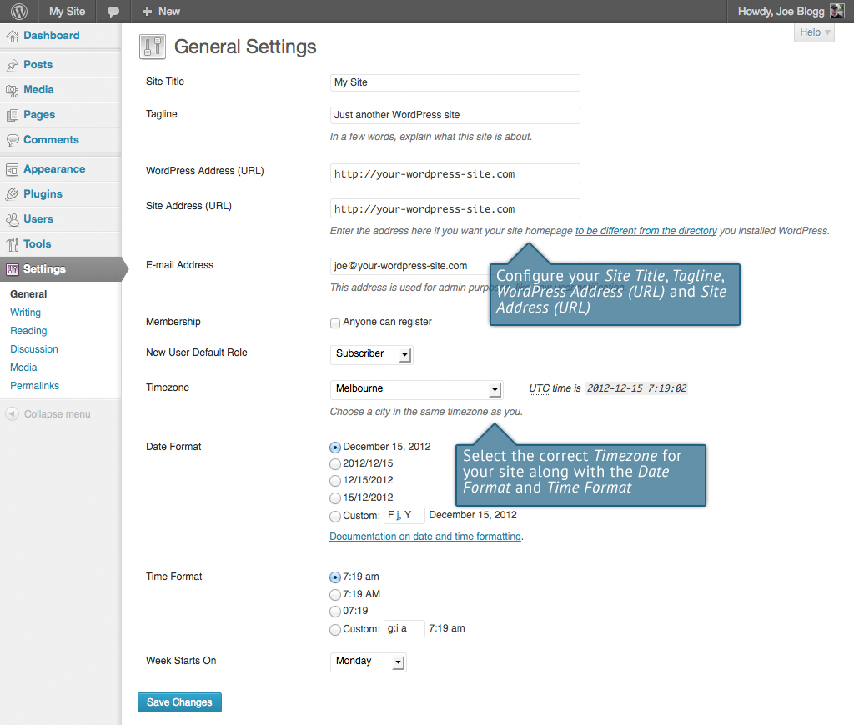

## Writing

The Writing settings configure various options with regards to writing your site content. Settings include defining the Default Post Category, Default Post Format (if supported by your Theme) and if the Link Manager plugin is installed, the Default Link Category.

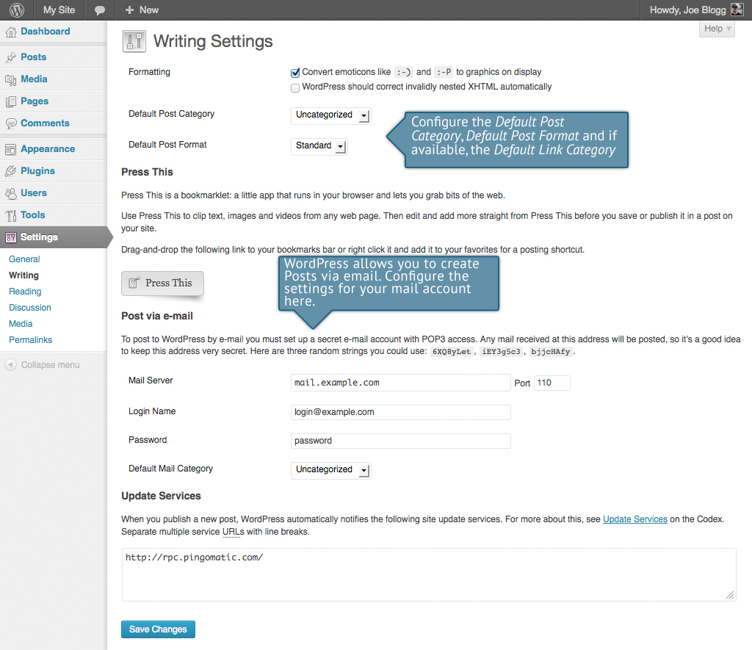

## Reading

The Reading settings configure how your site is viewed. You can define whether your front page displays a static Page or your blog Posts, how many blog posts are displayed by default as well as Syndication/RSS options. If you configure your site to display a static front page, you can set which page to display and also which page will show your blog posts.

The Search Engine Visibility setting enables you to block your site from search engines or allow it to be visible.

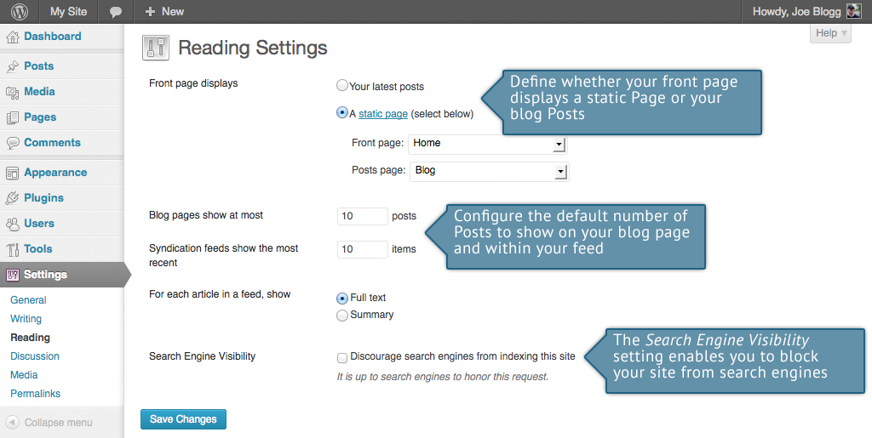

## Discussion

The Discussion settings define how your readers interact with your site and how your site interacts with other blogs. You can configure [Pingbacks](http://codex.wordpress.org/Introduction_to_Blogging#Pingbacks) and [Trackbacks](http://codex.wordpress.org/Introduction_to_Blogging#Trackbacks), whether readers can post Comments or not and if so, how those Comments are moderated and displayed on your site.

This screen also lets you configure whether the Post Author should be emailed whenever someone posts a comment on your site. If you are receiving emails whenever someone posts a comment, simply uncheck the box next to Anyone posts a comment within the E-mail me whenever section on this screen and then save your changes.

If you would like to be notified whenever a comment is held for moderation, it can be configured on this screen as well within the E-mail me whenever section. The email notification is sent to the email address listed in the Settings > General SubPanel.

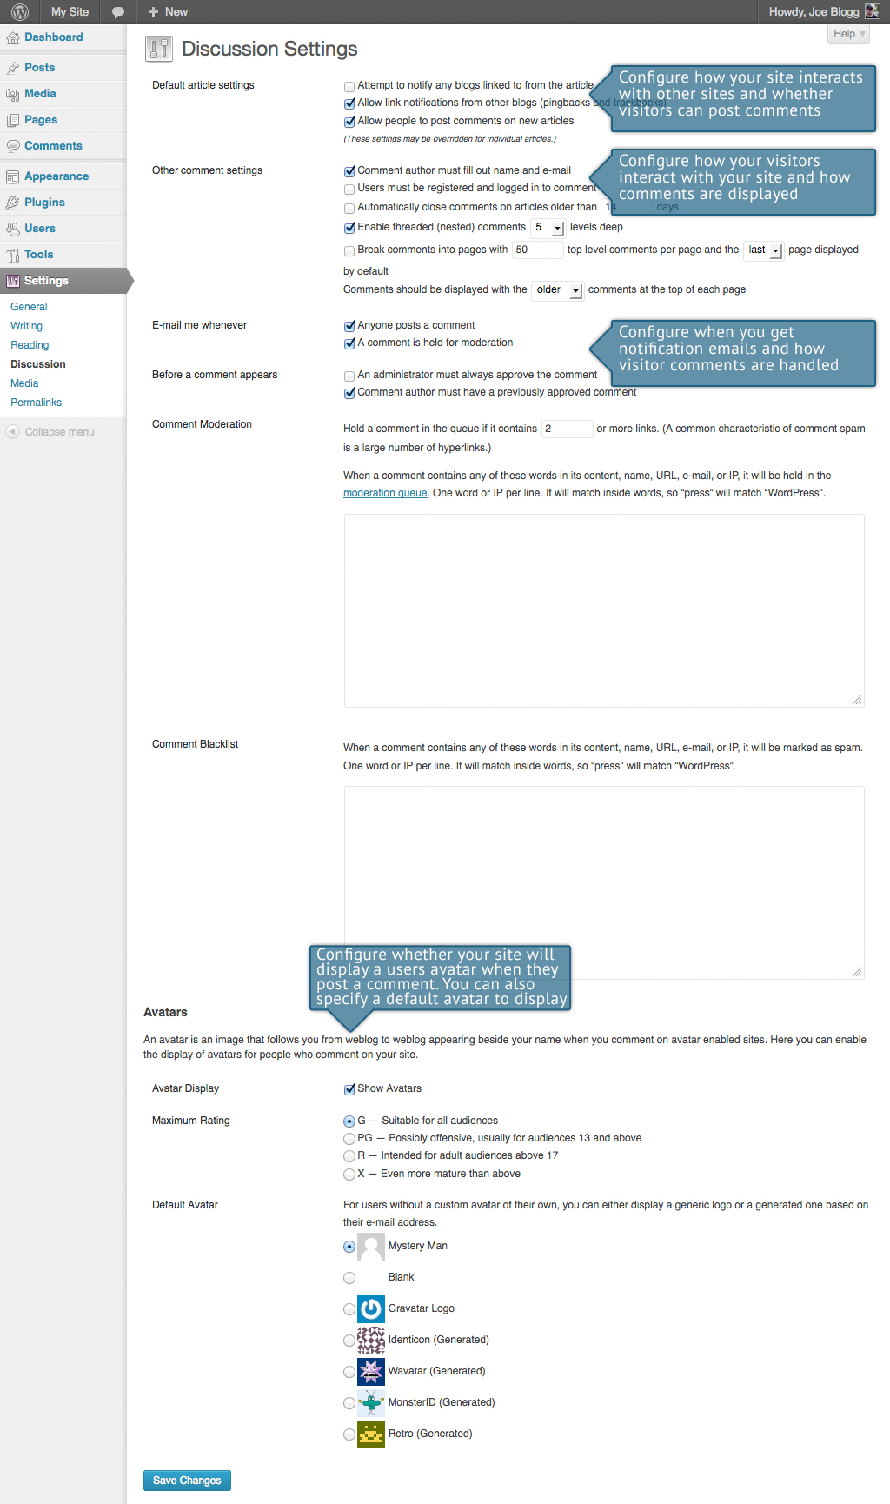

## Media

The Media settings define the default image sizes that are created when an image is uploaded.

You can also configure whether your uploaded media files are stored in folders based on the year and the month of the upload.

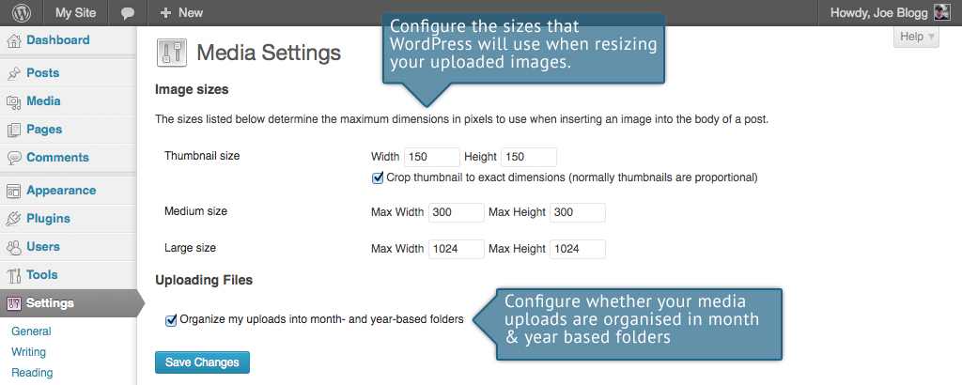

## Permalinks

The Permalink settings enable you to configure the URL format that is displayed in the web browser when someone browses your site. By default WordPress uses web URLs which have question marks and lots of numbers in them however you can change this so that the URL is more user friendly. This also helps considerably with Search Engine Optimisation (SEO). To change the way your site URL is displayed simply select one of the radio button options within the Common Settings section on this screen. Next to each option is an example of how the URL would be displayed.

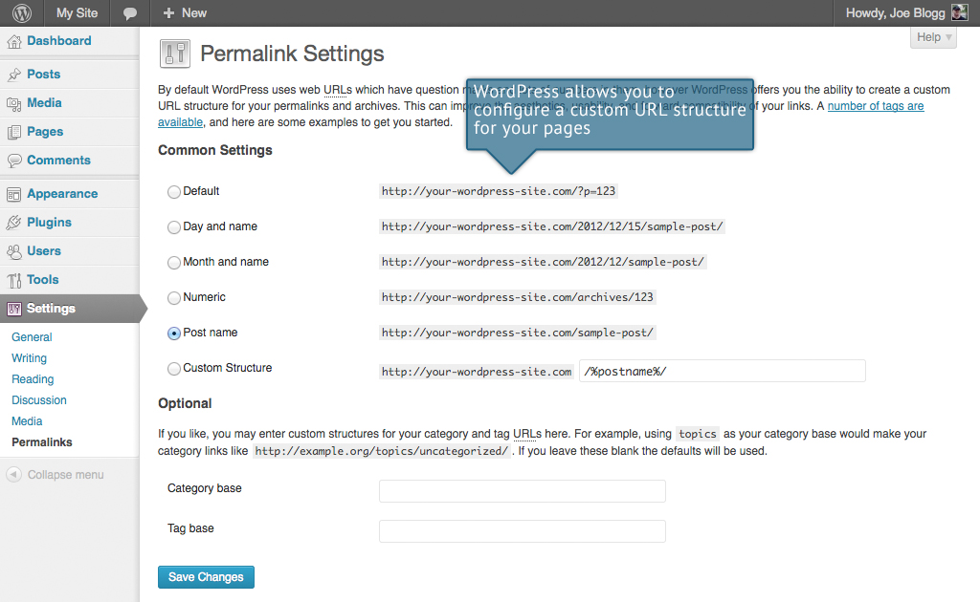

Where To From Here?

If you’re looking for more resources to further your WordPress knowledge the first place to check out is the [WordPress.org](http://wordpress.org) website. There you’ll find technical support and new resources like Plugins which are a fantastic way to add extra functionality to your site without having to modify your theme files. The [Plugin Directory](http://wordpress.org/extend/plugins/) has over 26,000 different plugins that are available to download. Furthermore, if you want to change how your site looks, have a look in the WordPress [Themes Directory](http://wordpress.org/extend/themes/) which is also there on the WordPress site.

If you find you need more information on a particular topic, have a search through the [WordPress Codex](http://codex.wordpress.org/Main_Page) which goes into greater detail about how WordPress works. Not only will you find information about updating your site content but there is all sorts of other useful information that will help you with installing WordPress, Troubleshooting, Using Plugins & Themes and also Theme Development, for the more technically minded.

Once your website is humming along nicely, you might want to think about getting involved in the awesome WordPress community. One of the easiest ways to get involved is simply by helping others within the [WordPress Support Forums](http://wordpress.org/support/). There is always someone there who’s newer to the learning curve than you, and learning is so much improved while you’re teaching others! There are topics there for all ability levels, from installation issues, theme and template issues, and general troubleshooting all the way through to more advanced areas of theme and plugin development.

It’s a great benefit not just for yourself, but for others as well in getting more involved in the WordPress community. This could be through core commits, UI design, testing beta releases or even just helping people on the WordPress forums. Or, how about getting along to meet ups where users and developers alike get together and learn from and teach each other, show off the projects they’re working on and meet others to collaborate with. The more we work together to make WordPress great, the more robust the platform becomes. Everyone wins!

Last but not least, don’t forget to keep in touch with us on the web;<http://easywpguide.com>